Appendix 9C-23 Manning’s Solution for

Flow in Storm Drains

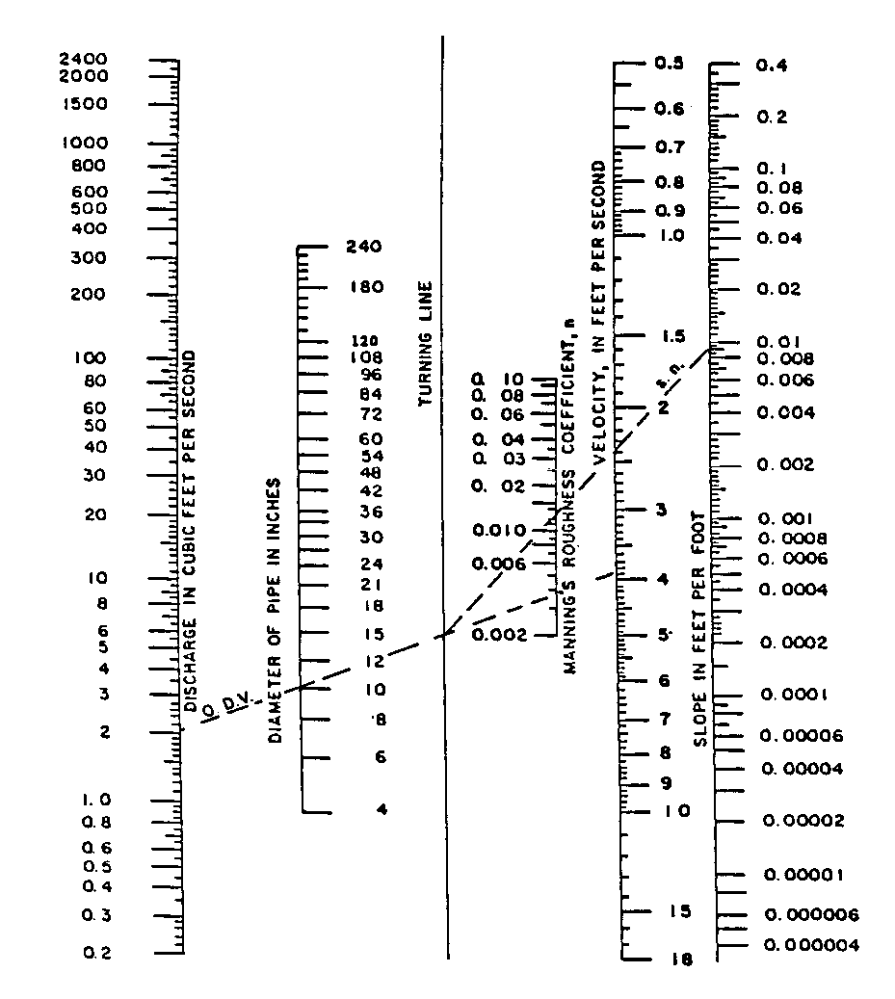

Source: HEC No. 22, FHWA

