Appendix 9C-22 Ratio of Frontal Flow to Total Flow

in a Trapezoidal Channel

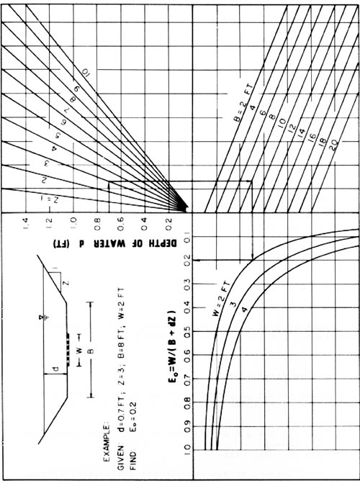

Source: HEC-12

