Appendix 9C-21 Curb-Opening Inlet Orifice Capacity for

Inclined and Vertical Orifice Throats

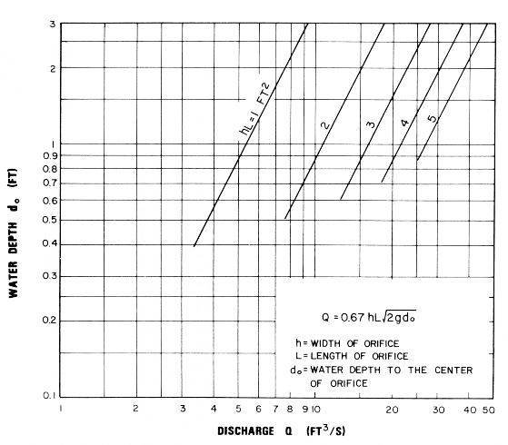

Source: HEC No. 12, FHWA

