Appendix 9C-16 Performance Curve DI-12 in a Sump

(Side Slope 6:1)

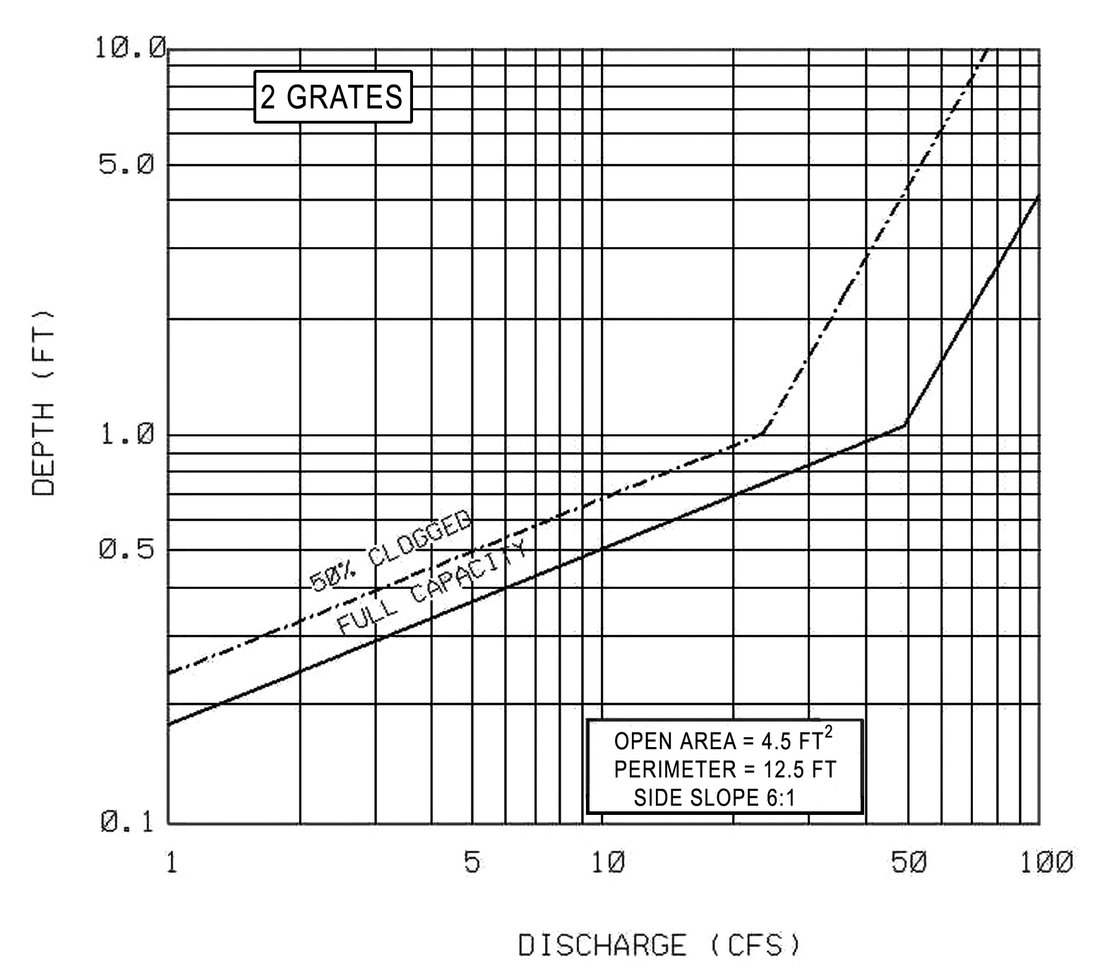

Source: VDOT

