Appendix 9C-15 Performance Curve DI-12 in a Sump

(Side Slope 3:1)

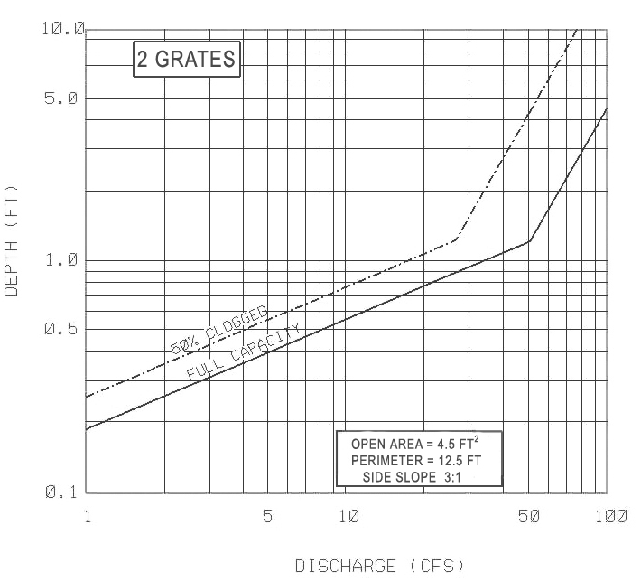

Comments and/or Source:

Source: VDOT

