Appendix 9C-13 Performance Curve DI-1 in a Sump

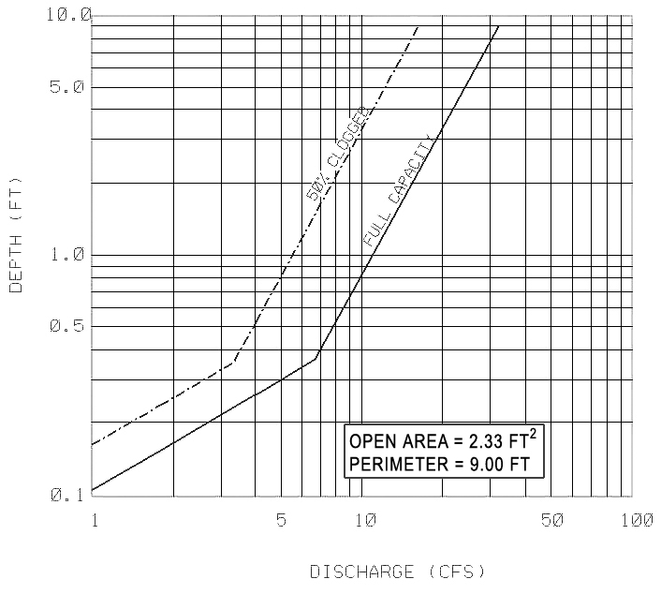

Source: VDOT

