Appendix 9C-7 Flow in Composite Gutter Sections

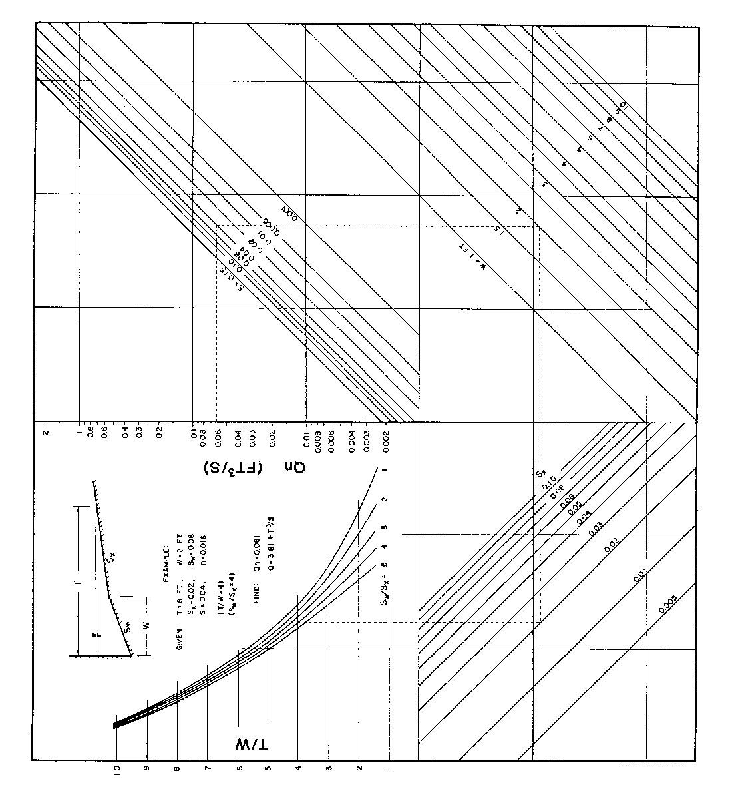

Source: HEC No. 12, FHWA

