Appendix 9C-5 Flow Characteristic Curves

(Straight Cross Slope 12” Gutter)
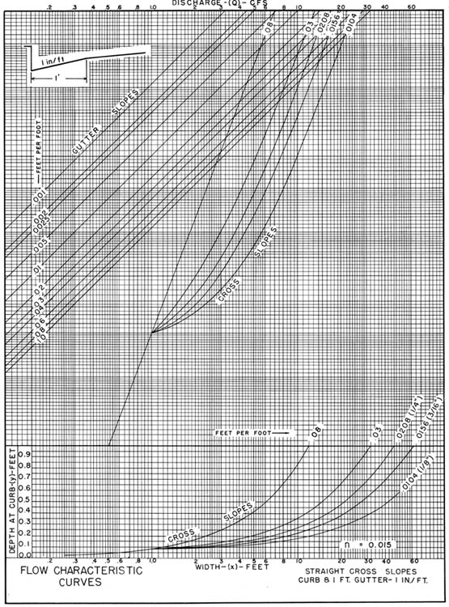

Source: VDOT

Comment: REV 6/85

