Appendix 9C-3 Flow Characteristic Curves

(24” Gutter) – VDOT Standard
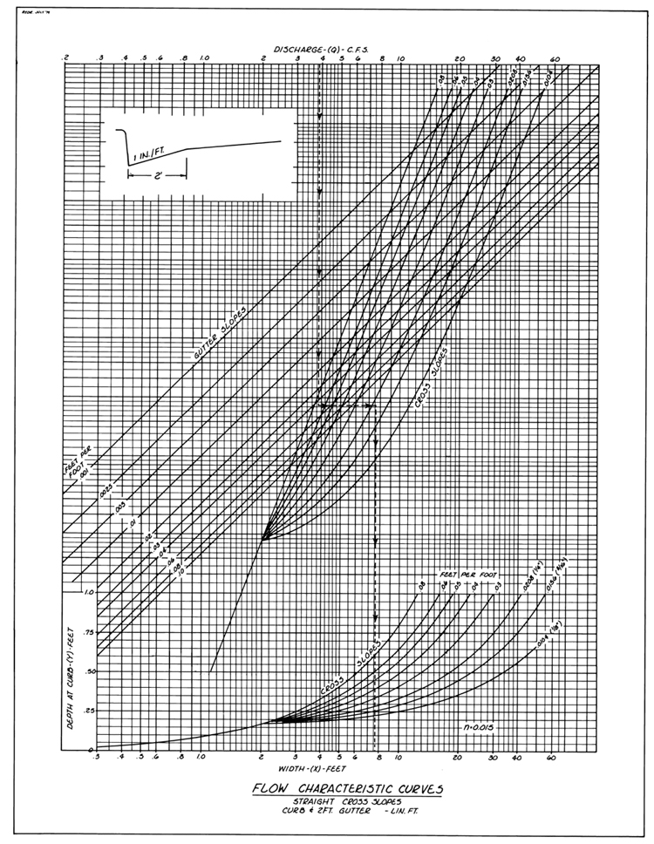

Source: VDOT

