Appendix 9C-2 Flow Characteristic Curves

(Straight Cross Slope with Curb)
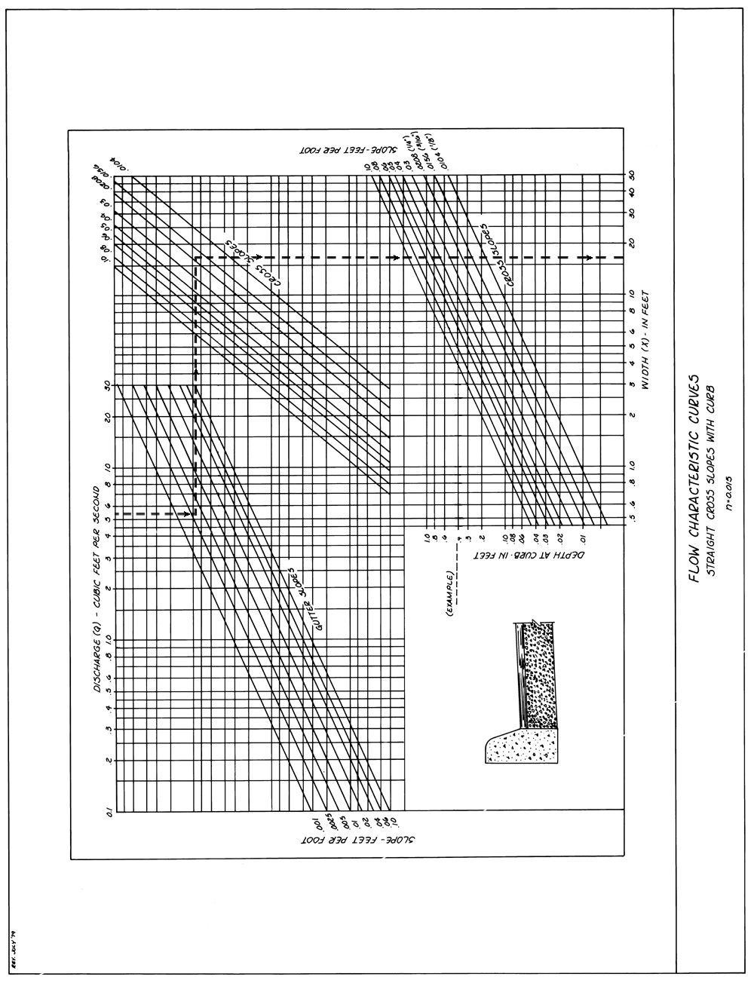

Source: VDOT
Comment: REV 6/81
REV 6/85

