Appendix 8F-6 Velocity Head and Resistance

Computations Factors

for Circular Conduits Flowing Full and Partly Full

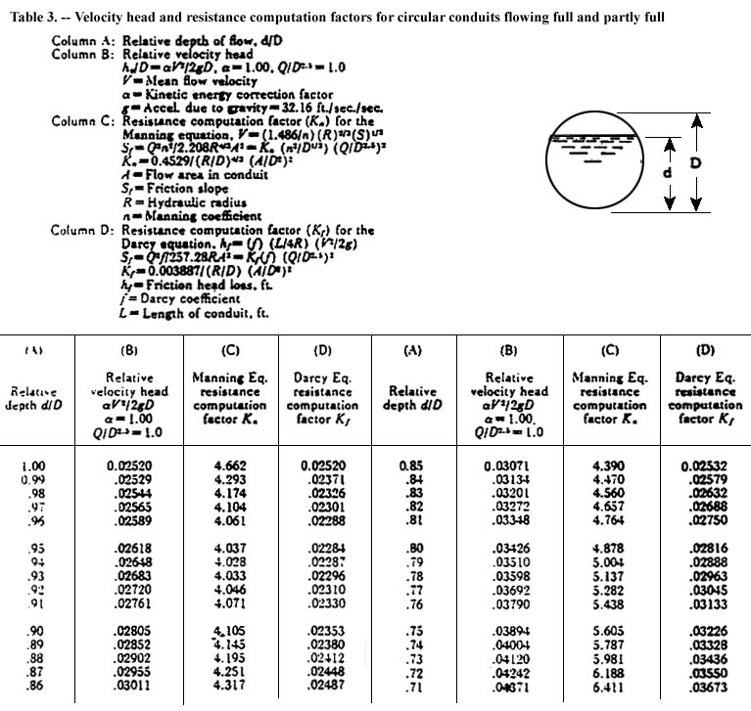

Source:

