Appendix 8F-5 Geometric Properties and

Critical Flow Factors for

Circular Conduits Flowing Full and Partly Full
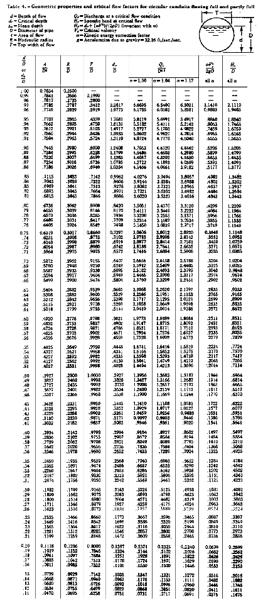
Source:

