8E.1 Riprap Basin

Riprap basins are used for energy dissipation at the outlets of high velocity culverts.

Riprap basin design is based on laboratory data obtained from full-scale prototypical installations. The principal features of riprap basins are as follows:

- Pre-shaping and lining with riprap of median size, d₅₀.
- Constructing the floor at a depth of h_{s} below the invert, where h_{s} is the depth of scour that would occur in a pad of riprap of size d₅₀.
- Sizing d₅₀ so that 2<h_{s}/d₅₀<4.
- Sizing the length of the dissipating pool to be 10(h_{s}) or 3(W_{o}), whichever is larger for a single barrel. The overall length of the basin is 15(h_{s}) or 4W_{o} whichever is larger.
5. Angular rock results are approximately the same as the results of rounded material.
6. Layout details and dimensions are shown on Figure 8E-1.

For high tailwater (), the following applies:

1. The high velocity core of water emerging from the culvert retains its jet-like character as it passes through the basin.
- The scour hole is not as deep as with low tailwater and is generally longer.
3. Riprap may be required for the channel downstream of the rock-lined basin.

8E.2 Design Procedures and Sample Problems

The procedure shown below should be used to determine the dimension for a riprap basin energy dissipator for culvert and pipe installations with pipe velocities greater than or equal to 19 feet per second as classified under Table 8-1 in Section 8.3.2.6. Maximum Outlet Velocity within the Chapter 8 text.

Step 1: Determine input flow parameters: D_{e} or d_{E,} V_{o}, F_{r} at the culvert outlet

Where:
d_{E} = Equivalent depth at the brink =
Note: d_{E} = y_{e} in Figure 8E-2

Step 2: Check TW

Determine if
Note: d_{o} = d_{E} in Figure 8E-2 for rectangular sections

Step 3 Determine d₅₀

a. Use Figure 8E-2.
b. Select d₅₀/d_{E}. Satisfactory results will be obtained if 0.25<d₅₀/d_{E}<0.45.
c. Obtain h_{s}/d_{E} using Froude number (F_{r}) and Figure 8E-2.
d. Check if 2<h_{s}/d₅₀<4 and repeat until a d₅₀ is found within the range.

Step 4: Size basin

a. As shown in Figure 8E-1.
b. Determine length of the dissipating pool, L_{s} = 10h_{s} or 3W_{o} minimum.
c. Determine length of basin, L_{B} = 15h_{s} or 4W_{o} minimum.

Thickness of riprap: Approach = 3d₅₀ or 1.5d_{max}
Remainder = 2W_{o} or 1.5d_{max}

Step 5: Determine exit velocity at brink (V_{B})

- Basin exit depth, d_{B} = critical depth at basin exit
b. Basin exit velocity,
- Compare V_{B} with the average normal flow velocity in the natural channel (V_{d})

Step 6: High tailwater design

- Design a basin for low tailwater conditions, Steps 1-5.
- Compute equivalent circular diameter (D_{E}) for brink area from:
- Estimate centerline velocity at a series of downstream cross sections using Figure 8E-4.
Size riprap using HEC -11 "Use of Riprap for Bank Protection.”¹

Step 7: Design Filter

The design filter is necessary unless the streambed material is sufficiently well graded. To deign a filter for riprap, use the procedures in Section 4.4 of HEC-11.

Dissipator geometry can also be computed using the "Energy Dissipator" module that is available in the microcomputer program HY8, Culvert Analysis.
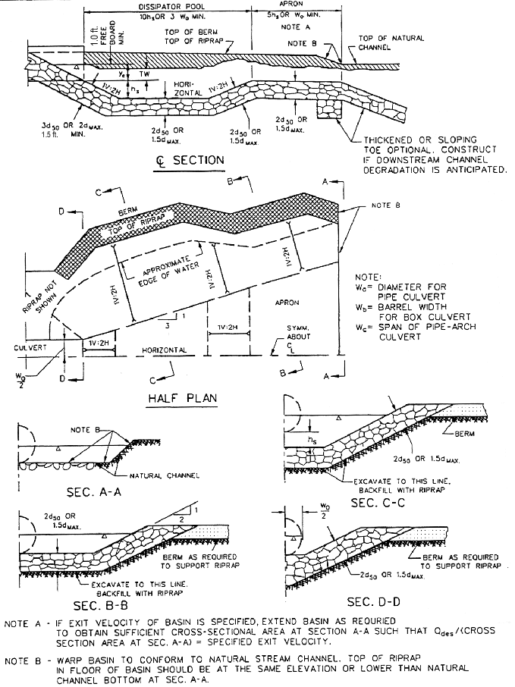
Figure 8E- . Details of Riprap Basin Energy Dissipator
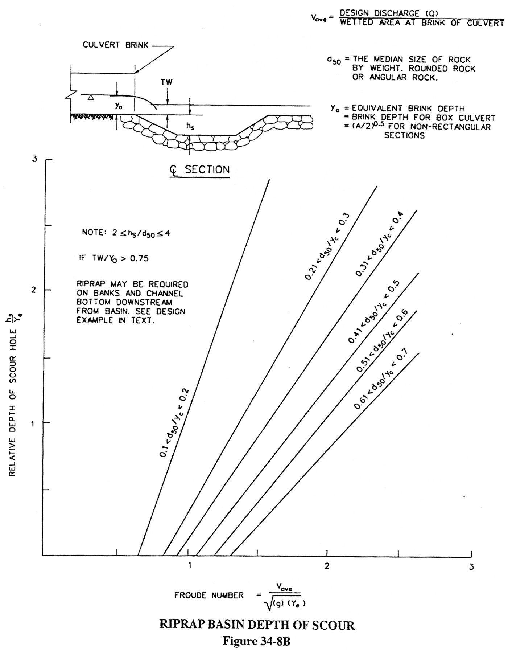

Figure 8E- . Riprap Basin Depth of Scour

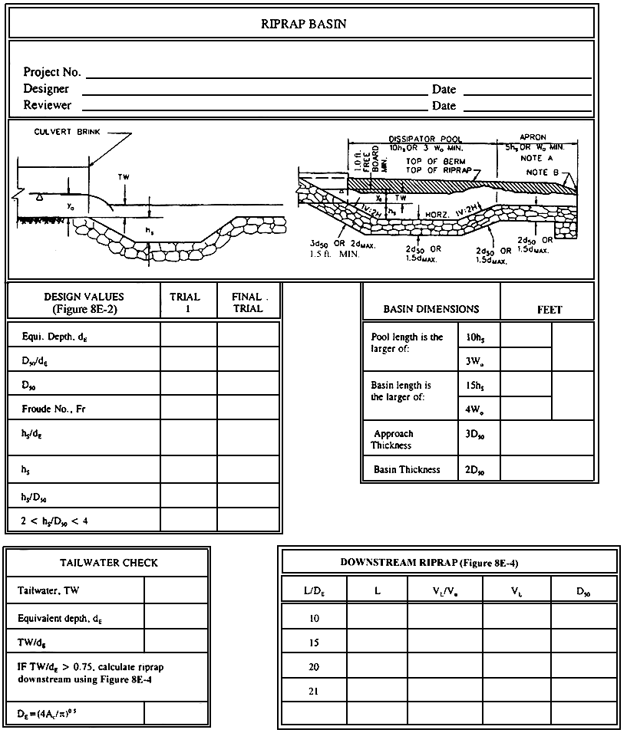
Figure 8E- . Riprap Basin Design Checklist

8E.2.1 Riprap Design for Low Tailwater Condition-Sample Problem

Given: Box culvert: 8.0 ft by 6.0 ft.

Design discharge Q = 800 cfs
Supercritical flow in culvert
Normal flow depth d_{o} = brink depth d_{E} = 4.0 ft
Tailwater depth, TW = 2.8 ft
Downstream channel velocity = 18 fps

Step 1: Determine input flow parameters: D_{e} or d_{E,} V_{o}, F_{r} at the culvert outlet

d_{o} = d_{E} for rectangular section
d_{o} = d_{E} = 4.0 ft.

Step 2: Check TW:

Determine if
Therefore, , O.K.

Step 3: Determine d₅₀:

- Use Figure 8E-2

- Try d₅₀/d_{E} = 0.45
c. Obtain h_{S}/d_{E} using F_{r} = 2.2 and line

h_{S}/d_{E} = 1.6
d. Check if 2<h_{S}/d₅₀<4:

2 <3.55<4, O.K.

Step 4: Size the basin:

- As shown in Figure 8E-1
b. Determine length of dissipating pool, L_{S}:
L_{S} = 10h_{S} = 10(6.4) = 64 ft.
L_{S} min.= 3W_{o} = 3(8) = 24 ft
Therefore, use L_{S} = 64 ft
c. Determine length of basin, L_{B}:
L_{B} = 15h_{S} = 15(6.4) = 96 ft
L_{B} min. = 4W_{o} = 4(8) = 32 ft
Therefore, use L_{B} = 96 ft
d. Thickness of riprap:
Approach = 3d₅₀ = 3(1.80) = 5.4 ft
Remainder = 2d₅₀ = 2(1.80) = 3.6 ft

Step 5: Determine V_{B}:

- d_{B} = Critical depth at basin exit = 3.30 ft. (assuming a rectangular cross section with width W_{B} = 24 ft.)
c. V_{B} =10 fps <V_{d} = 18 fps

8E.2.2 Riprap Design for High Tailwater Condition-Sample Problem

Given: Data on the channel and the culvert are the same as Sample Problem 1, except that the new tailwater depth,

TW = 4.2 ft.
Downstream channel can tolerate only 7.0 fps

Steps 1 through 5 are the same as Sample Problem 8E.2.1.

Step 6: High tailwater design:

- Design a basin for low tailwater conditions, Steps 1-5 as above:
D₅₀ = 1.8 ft, h_{S} = 6.4 ft
L_{S} = 64 ft, L_{B} = 96 ft
b. Compute equivalent circular diameter, D_{E}, for brink area from:
V_{o} = 25 fps (Sample Problem 8E.2.1).
c. Estimate centerline velocity at a series of downstream cross sections using Figure 8E-5.

 | L |  | V_{L} | D₅₀²
10 | 64 | 0.59 | 14.7 | 1.4
15³ | 96 | 0.36 | 9.0 | 0.6
20 | 128 | 0.30 | 7.5 | 0.4
21 | 135 | 0.28 | 7.0 | 0.4

¹ Use W_{o} = D_{E} in Figure 8E- .
² From Figure 8E- .
³ Is on a logarithmic scale so interpolations must be performed logarithmically.

d. Size riprap using HEC 11. The channel can be lined with the same size rock used for the basin. Protection should extend at least 135 ft downstream.
This information is summarized in the worksheet for riprap basin design, Figure 8E- .
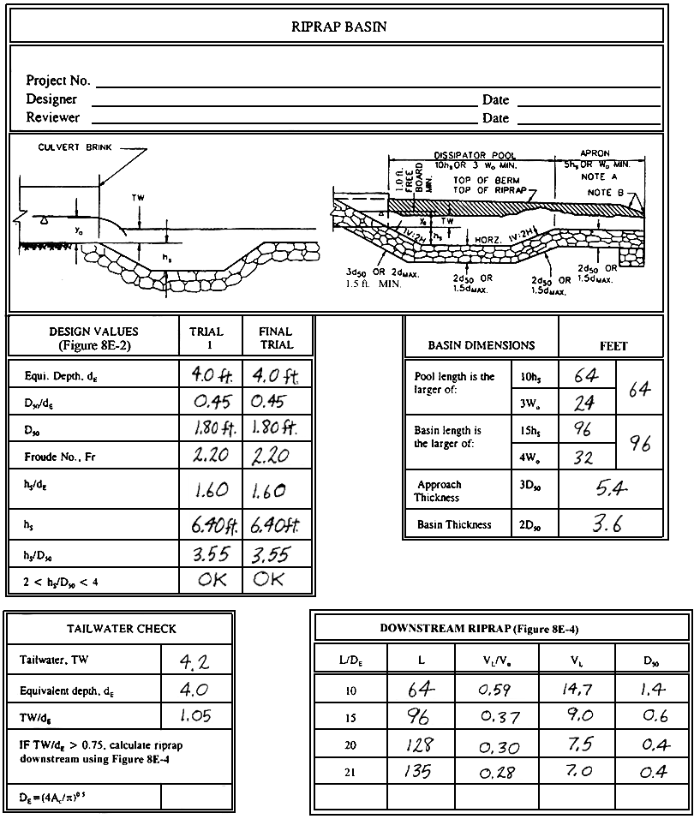

Figure 8E- . Riprap Basin Design Worksheet, Sample Problem
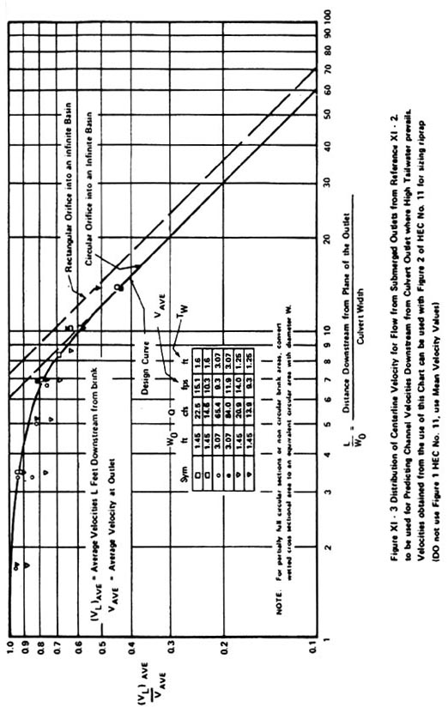
Figure 8E- . Distribution of Centerline Velocity for Flow from Submerged Outlets
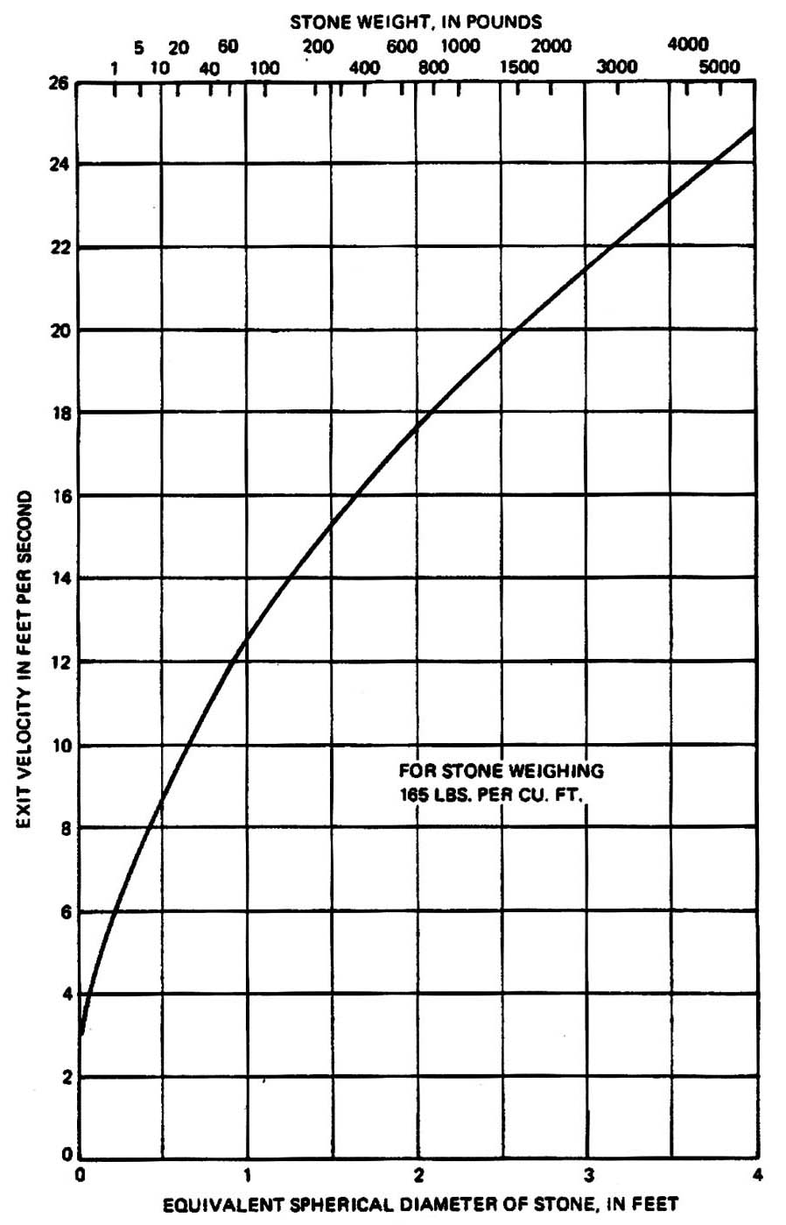
Figure 8E- . Riprap Size Versus Exit Velocity

8E.2.3 Computer Output

The dissipator geometry can be computed using the “Energy Dissipator” module, which is available in FHWA’s HY8, Culvert Analysis microcomputer program. The output of the culvert data, channel input data, and computed geometry using this module are shown below.

FHWA CULVERT ANALYSIS, HY-8, VERSION 6.0

CURRENT DATE CURRENT TIME FILE NAME FILE DATE
06-02-1997 15:23:59 ENERGY3 06-02-1997
CULVERT AND CHANNEL DATA

CULVERT NO. 1 DOWNSTREAM CHANNEL
CULVERT TYPE: 8.0 ft X 6.0 ft, BOX CHANNEL TYPE: IRREGULAR
CULVERT LENGTH = 300 ft BOTTOM WIDTH = 8.0 ft
NO. OF BARRELS = 1.0 TAILWATER DEPTH = 2.8 ft
FLOW PER BARREL= 400 cfs TOTAL DESIGN FLOW = 400 cfs
INVERT ELEVATION = 172.5 ft BOTTOM ELEVATION = 172.5 ft
OUTLET VELOCITY = 25 fps NORMAL VELOCITY = 32 fps
OUTLET DEPTH = 4.0 ft

RIPRAP STILLING BASIN – FINAL DESIGN

THE LENGTH OF THE BASIN = 96.3 ft
THE LENGTH OF THE POOL = 64.2 ft
THE LENGTH OF THE APRON = 32 ft
THE WIDTH OF THE BASIN AT THE OUTLET = 8.0 ft
THE DEPTH OF POOL BELOW CULVERT INVERT = 6.4 ft
THE THICKNESS OF THE RIPRAP ON THE APRON = 6.6 ft
THE THICKNESS OF THE RIPRAP ON THE REST OF THE BASIN = 5.0 ft
THE BASIN OUTLET VELOCITY = 17 fps
THE DEPTH OF FLOW AT BASIN OUTLET = 6.0 ft

