Appendix 8C-82 Rectangular Channel Flow Chart (B=6’)
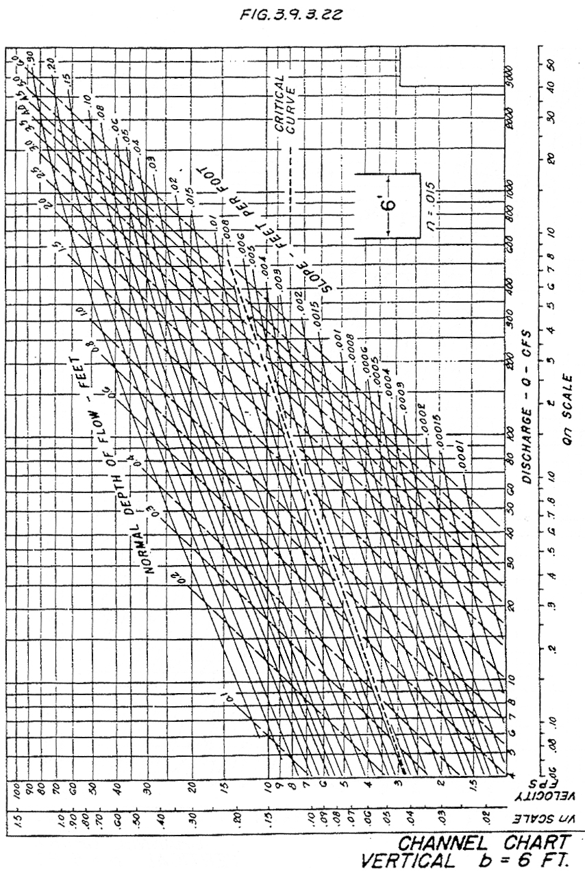
Source: HDS-3

