Appendix 8C-78 Rectangular Channel Flow Chart (B=2’)

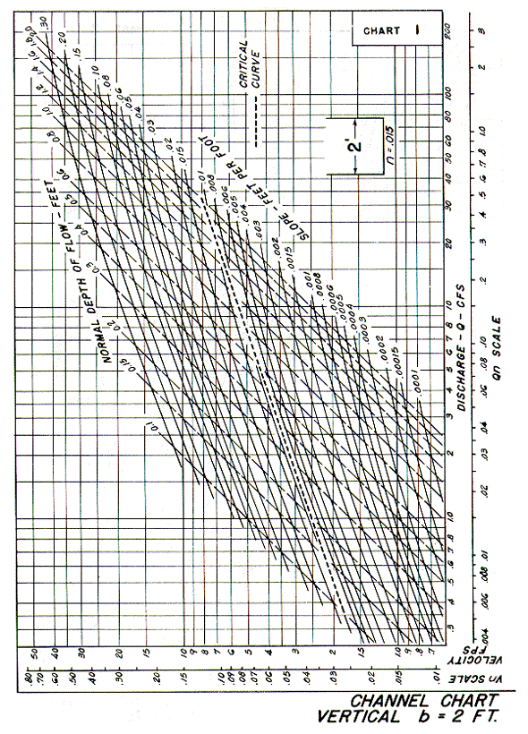
Source: HDS-3

