Appendix 8C-76 Circular Pipe Flow Chart (Diameter = 84”)
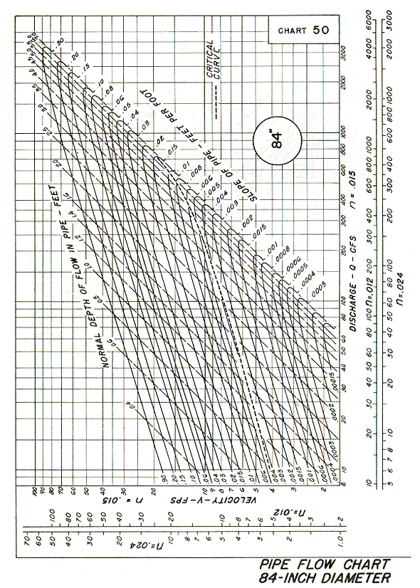
Source: HDS-3

