Appendix 8C-72 Circular Pipe Flow Chart (Diameter = 54”)
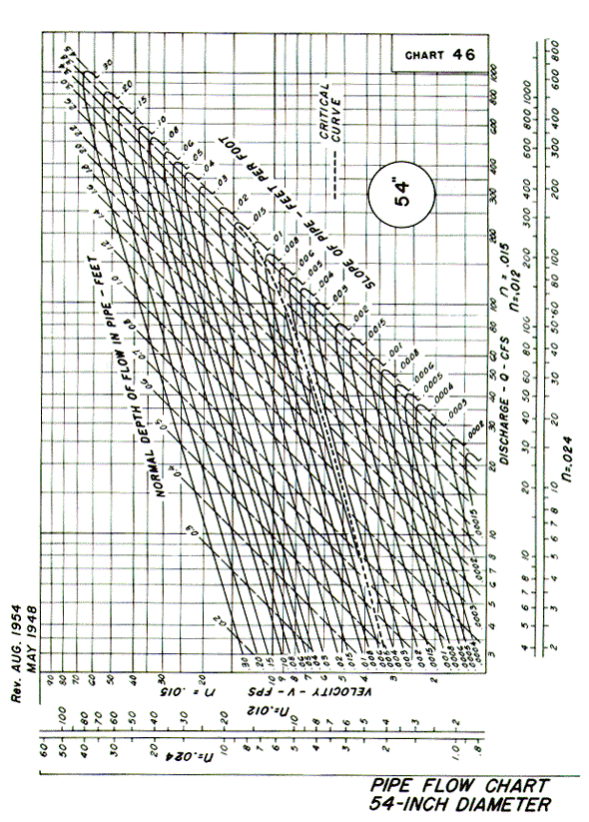
Source: HDS-3

