Appendix 8C-69 Circular Pipe Flow Chart (Diameter = 36”)
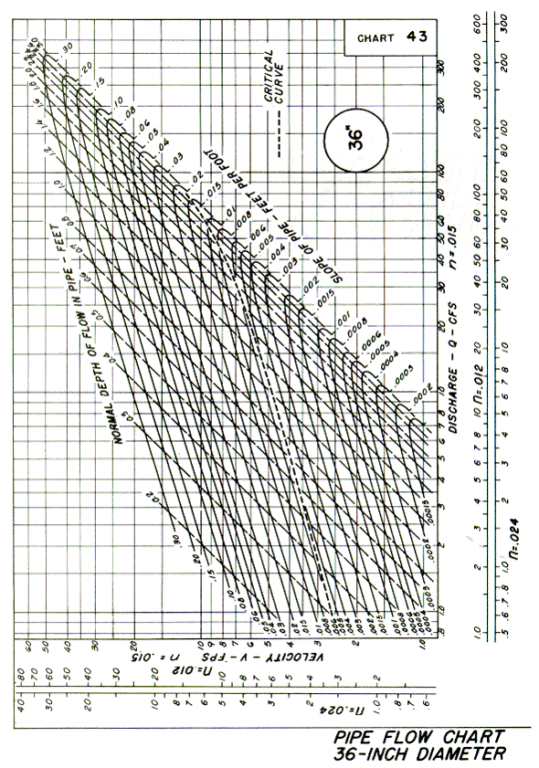
Source: HDS-3

