Appendix 8C-65 Circular Pipe Flow Chart (Diameter = 24”)
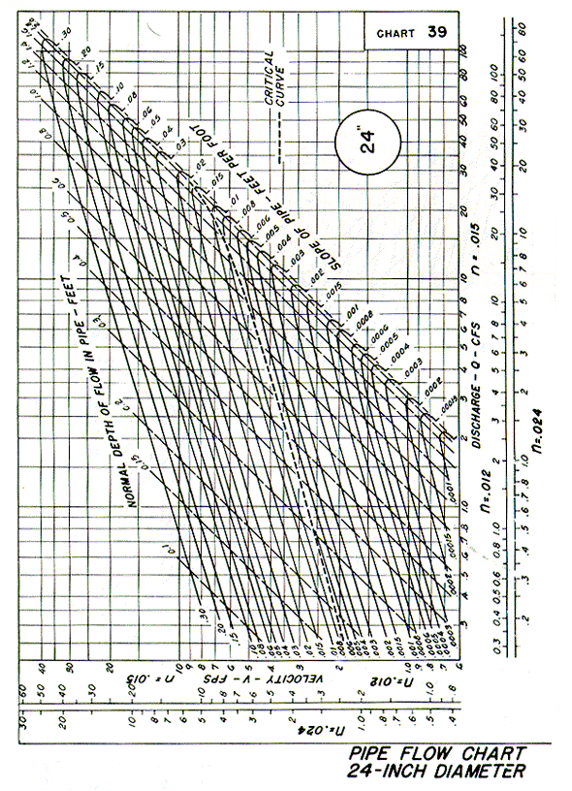
Source: HDS-3

