Appendix 8C-61 Circular Pipe Flow Chart (Diameter = 12”)
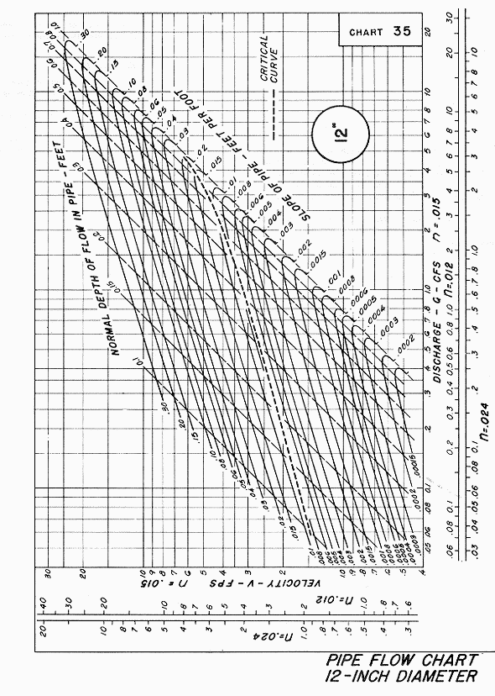
Source: HDS-3

