Appendix 8C-59 Face Control, Box Section, Slope-Tapered
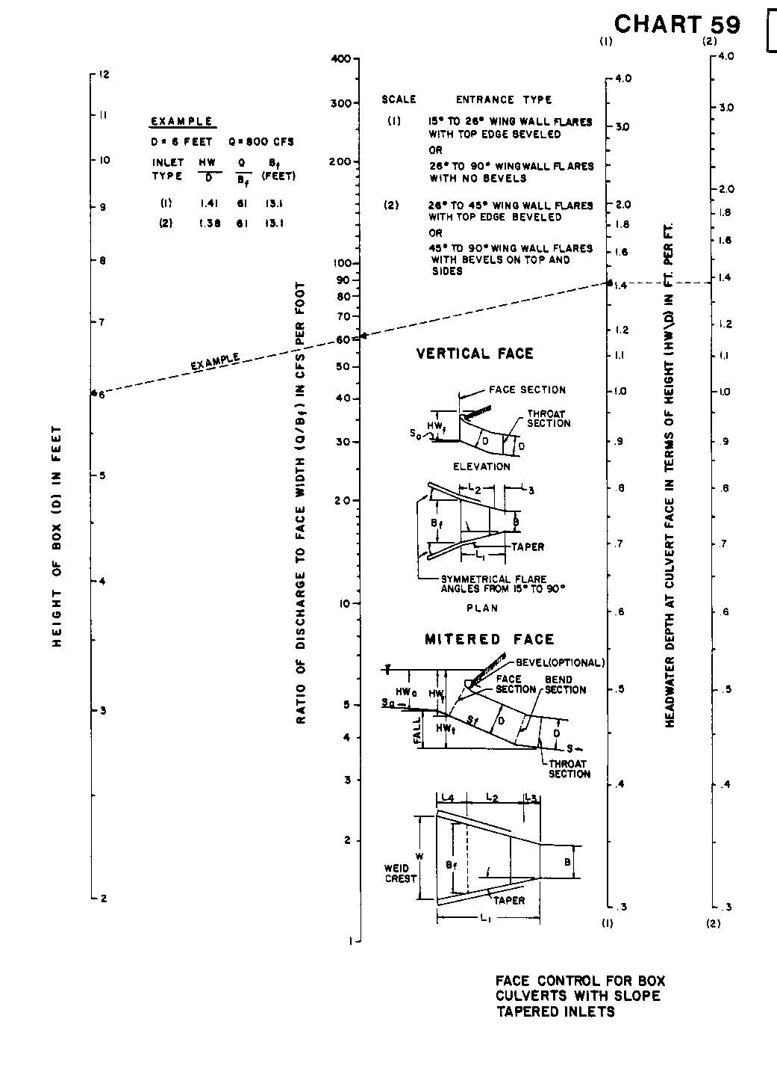

Source: HDS-5

