Chart 8C-55 Throat Control, Circular Section, Side-Tapered
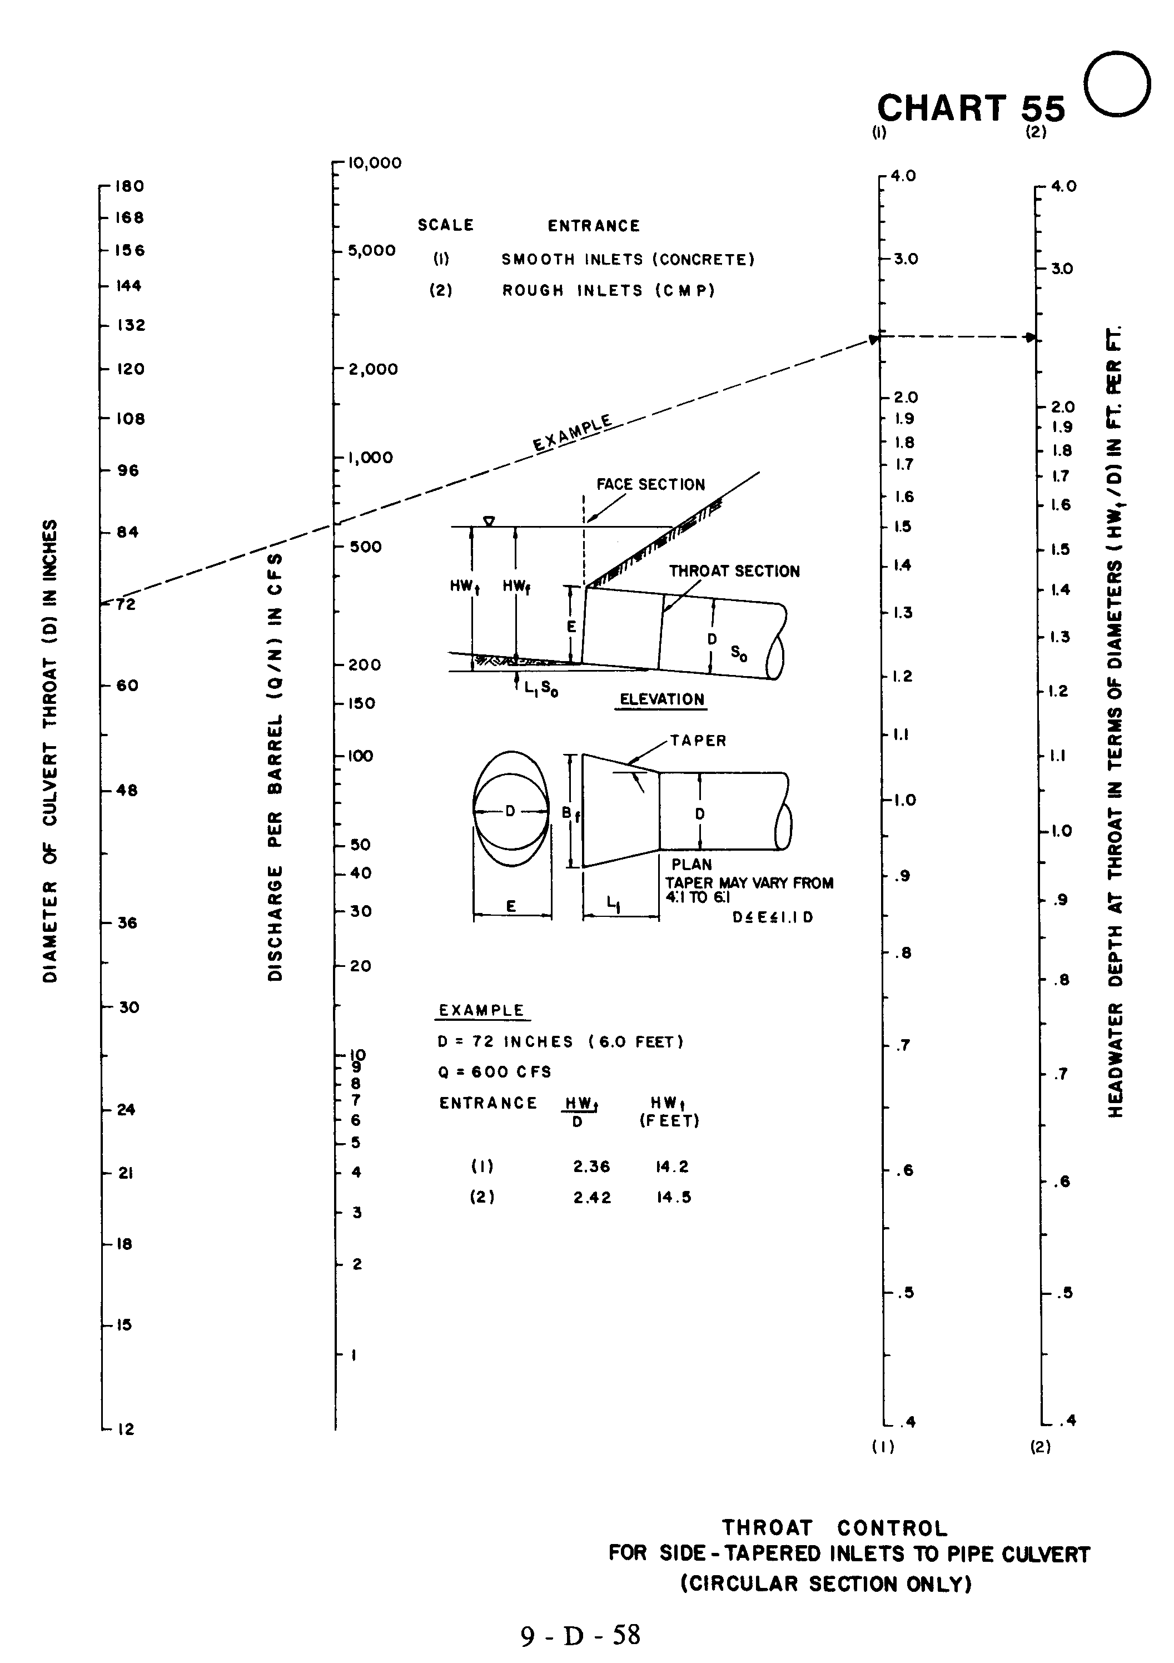

Source: HDS-5

