Appendix 8C-54 Critical Depth, Structural Plate Arch,

Low and High Profile

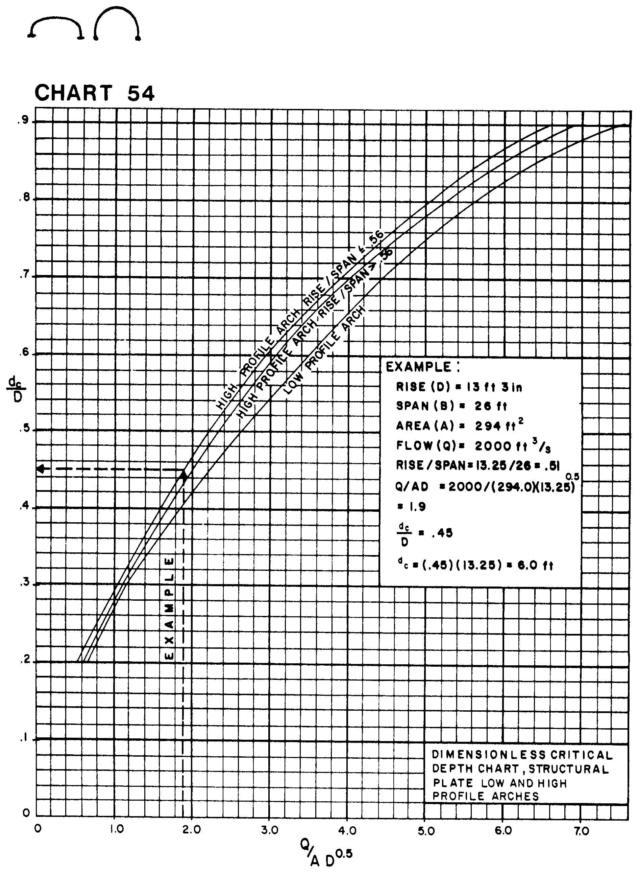

Source: HDS-5

