Appendix 8C-51 Inlet Control,

Structural Plate Corrugated Metal,

Circular or Elliptical
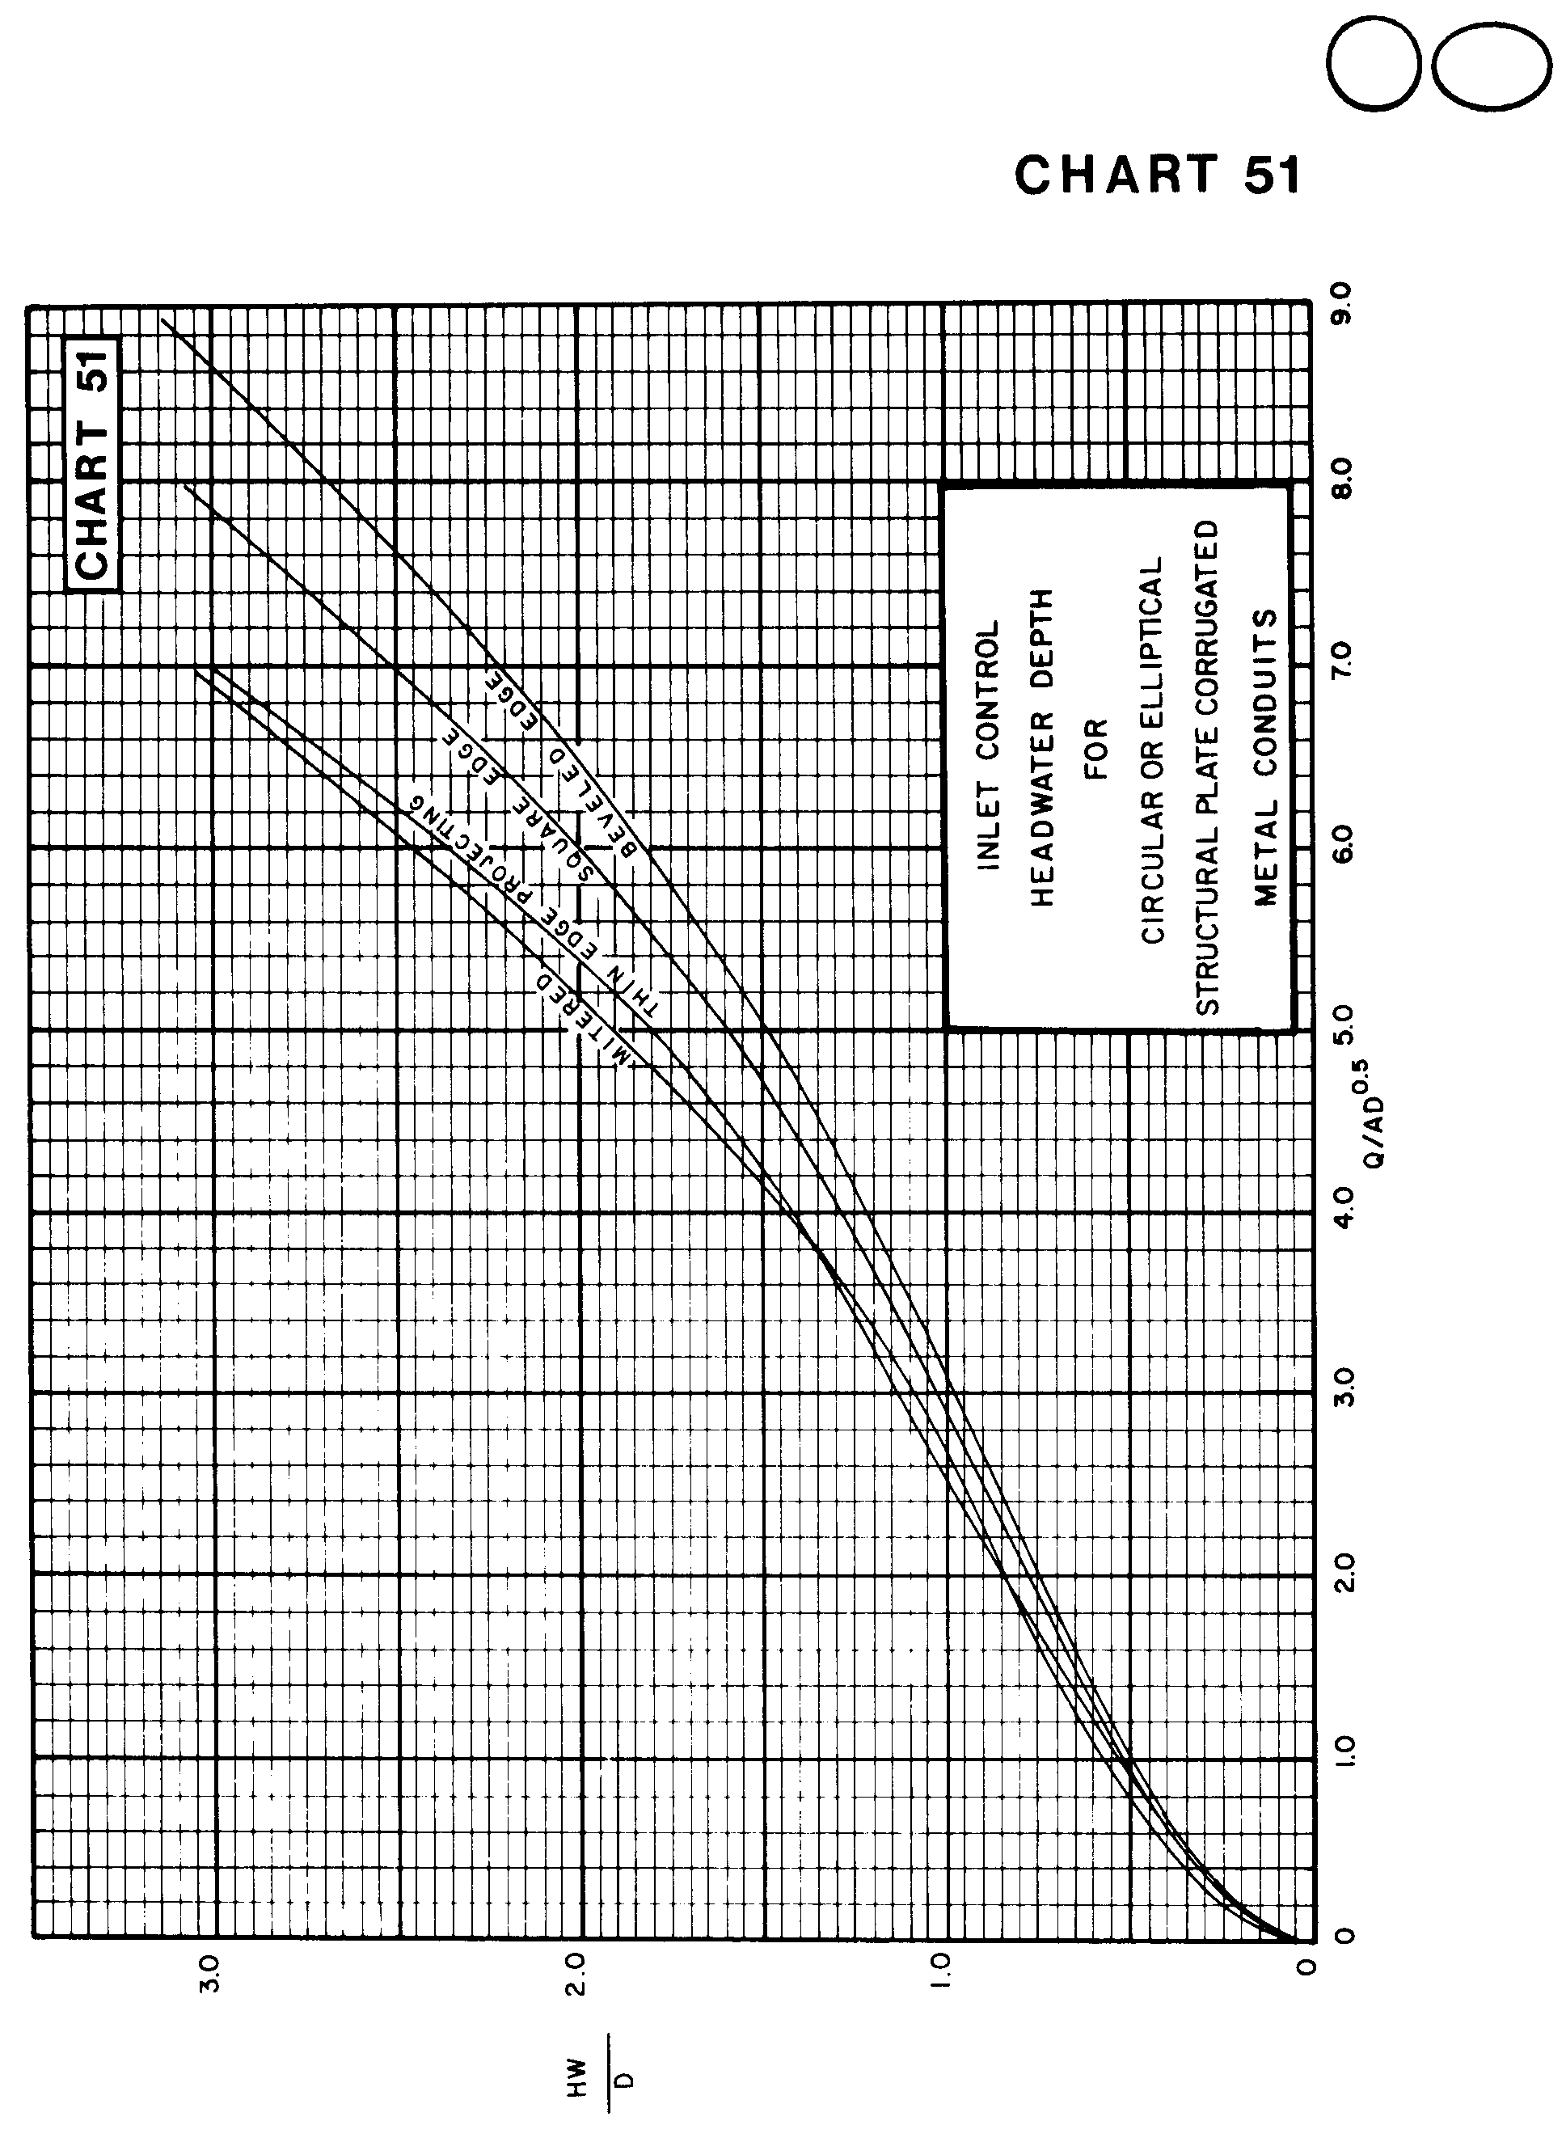

Source: HDS-5

