Appendix 8C-48 Outlet Control, Corrugated Metal Arch,

Earth Bottom,

0.3≤ Rise/Span <0.4
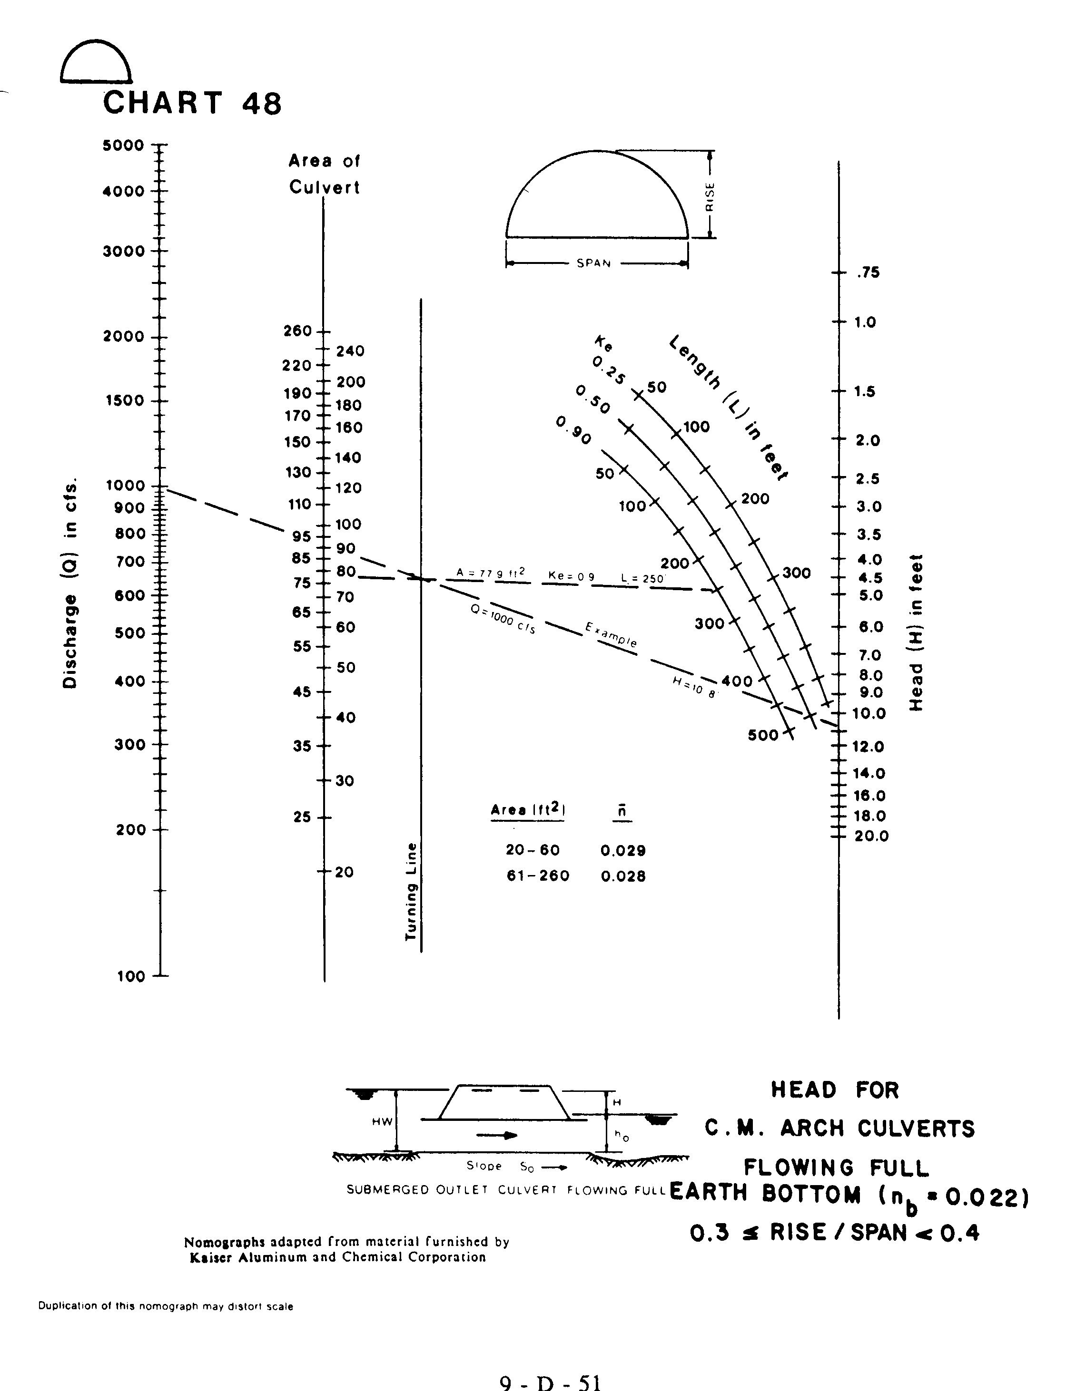
Source: HDS-5

