Appendix 8C-46 Outlet Control, Corrugated Metal Arch,

Concrete Bottom,

0.4≤ Rise/Span <0.5
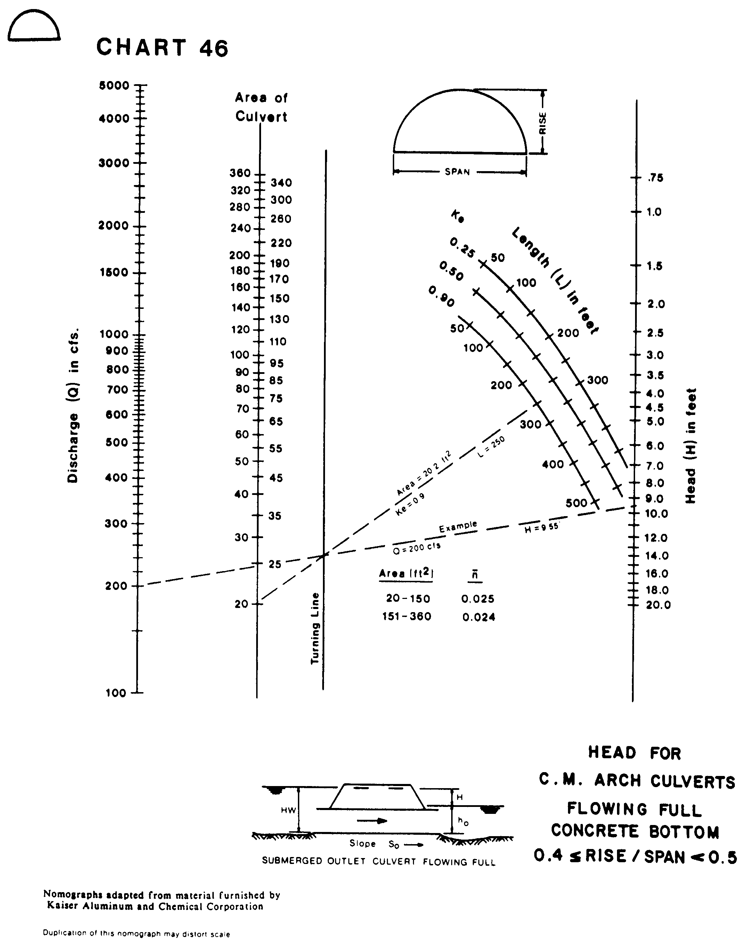
Source: HDS-5

