Appendix 8C-45 Outlet Control, Corrugated Metal Arch,

Concrete Bottom,

0.3≤ Rise/Span <0.4
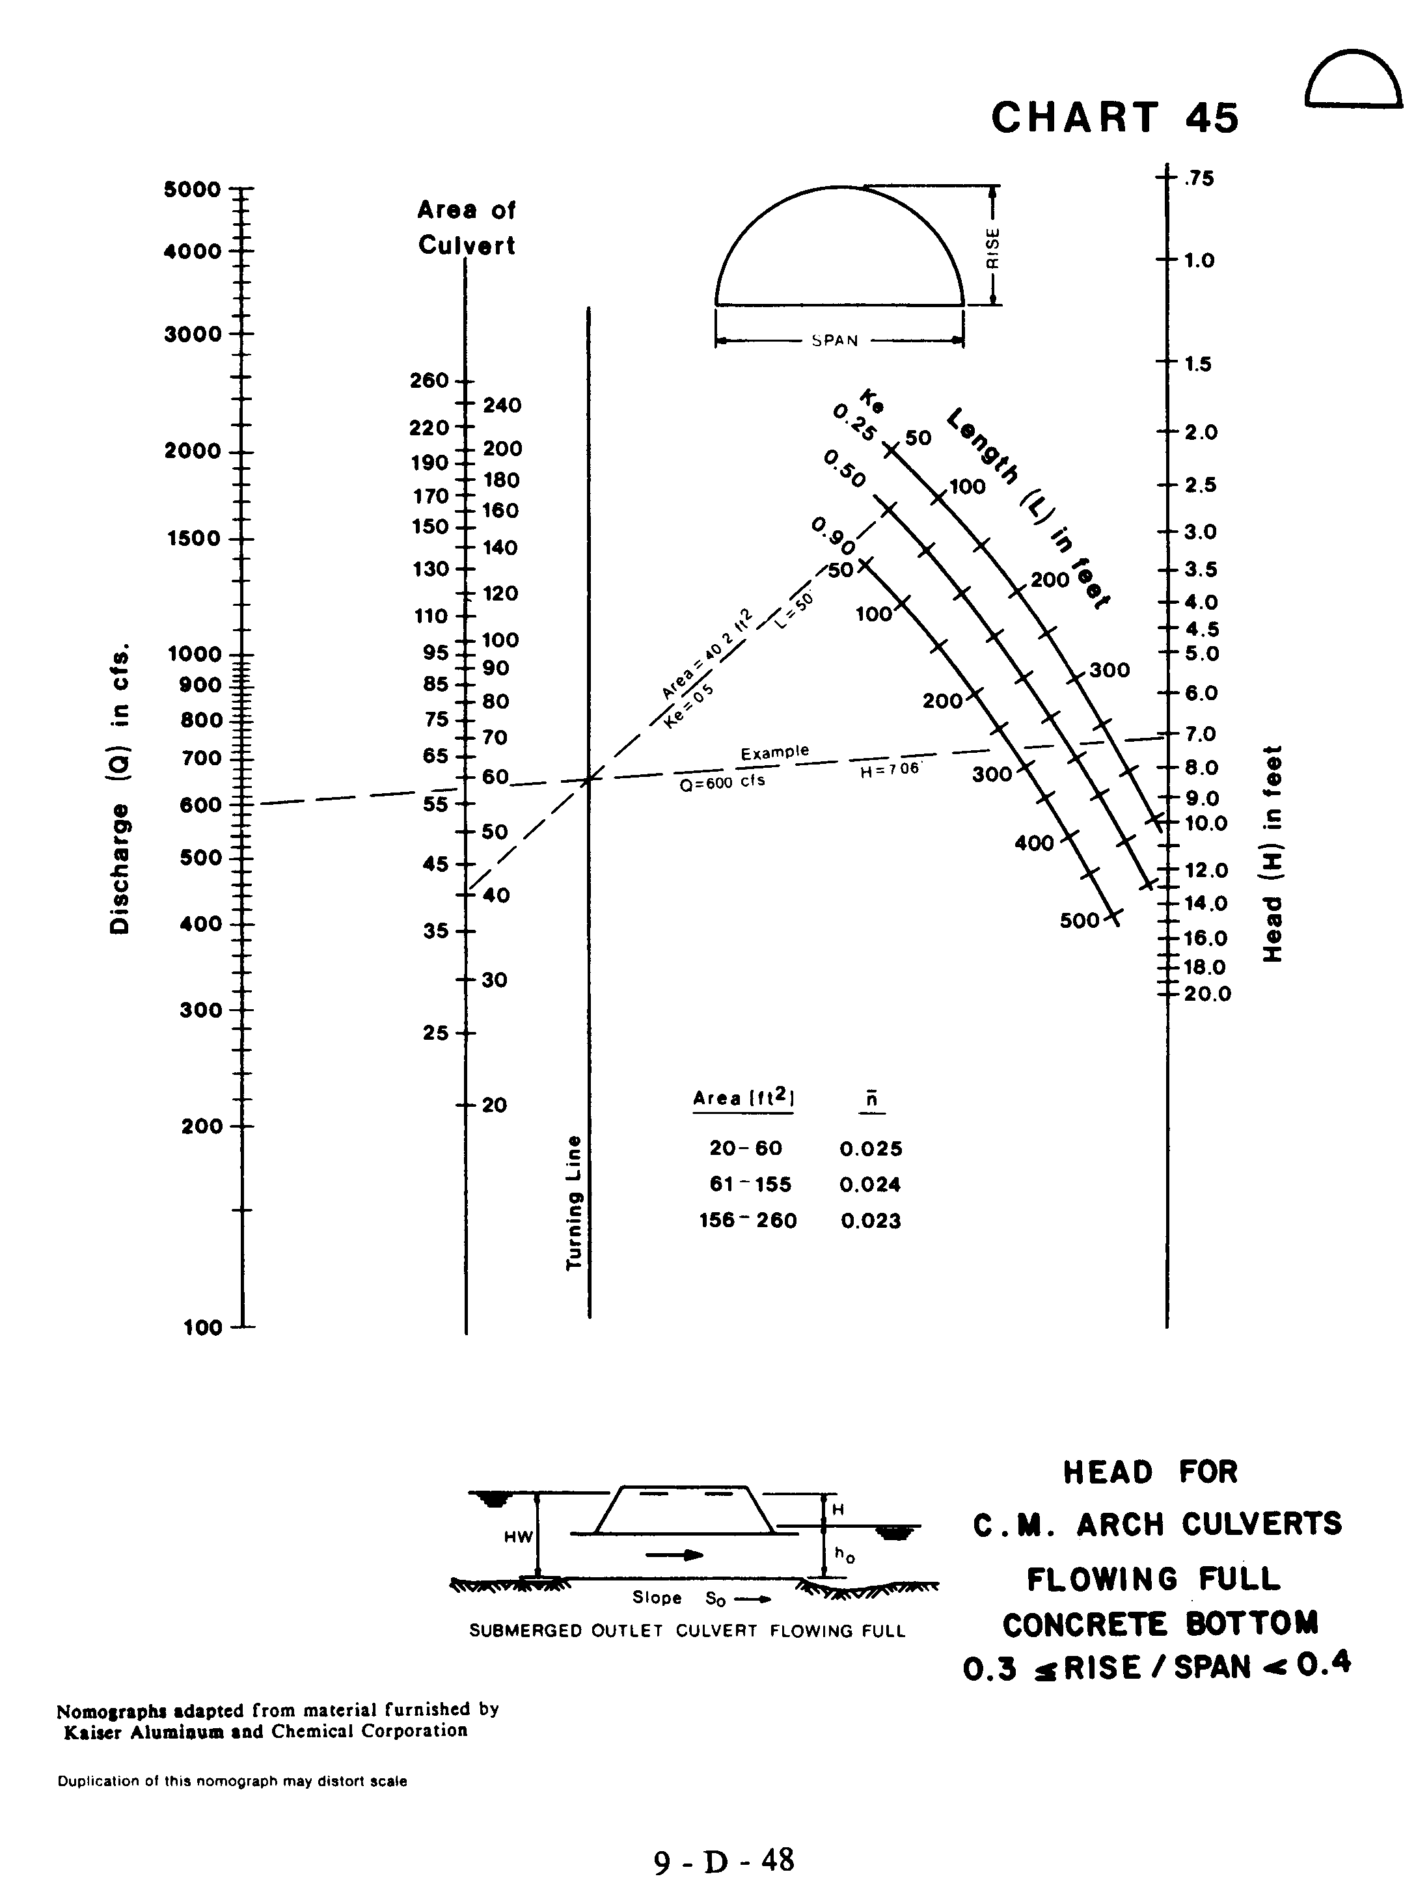
Source: HDS-5

