Appendix 8C-43 Inlet Control, Corrugated Metal Arch,

0.5≤ Rise/Span
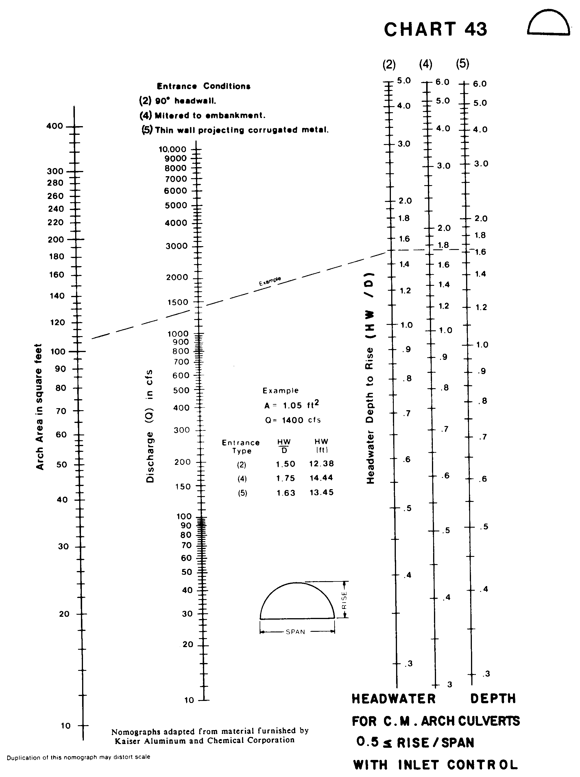

Source: HDS-5

