Appendix 8C-33 Outlet Control, Oval Concrete,

Long Axis Horizontal or Vertical
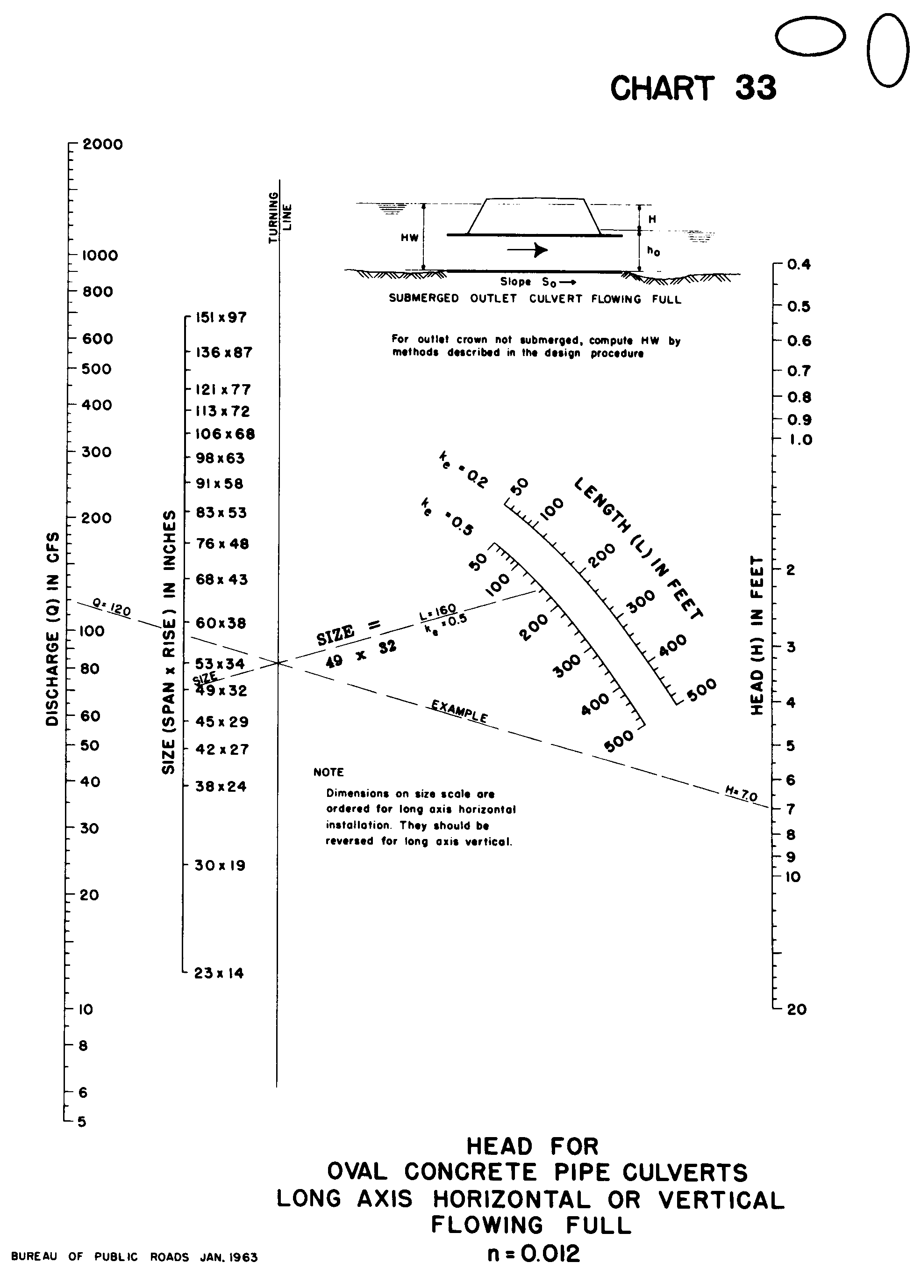

Source: HDS-5

