Appendix 8C-31 Critical Depth, Oval Concrete,

Long Axis Horizontal

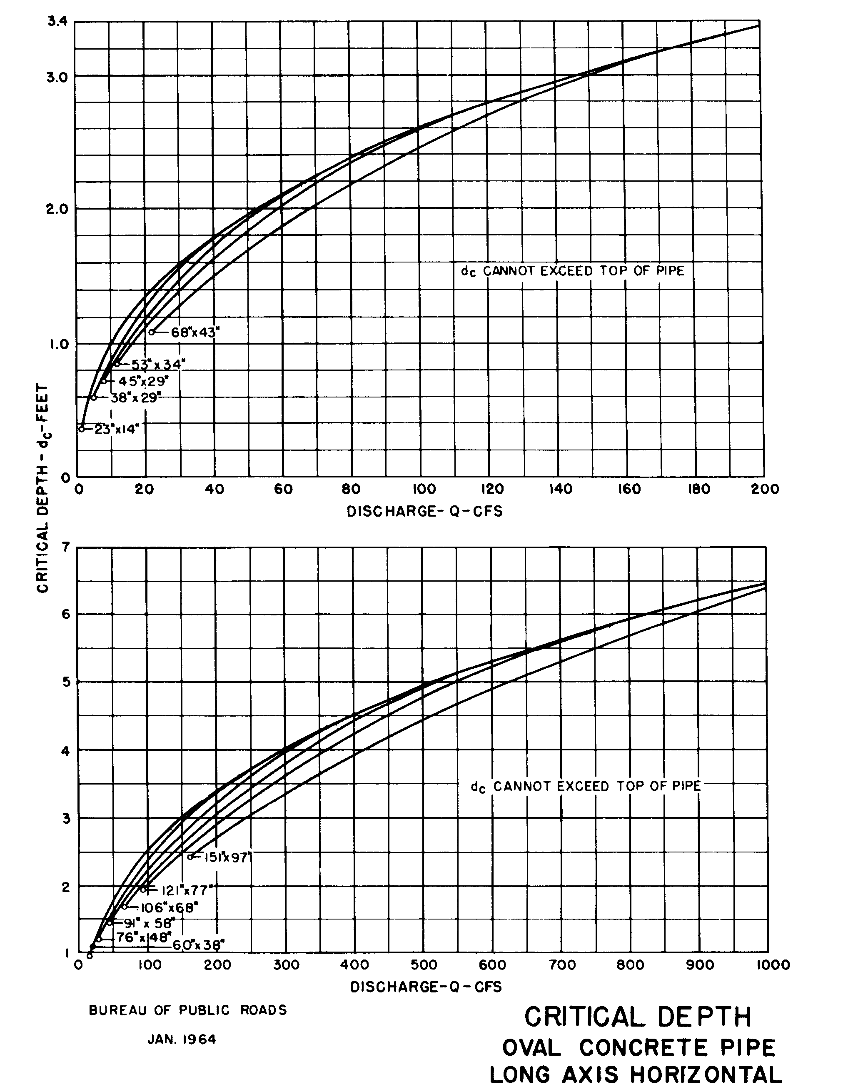

Source: HDS-5

