Appendix 8C-25 Outlet Control, Corrugated Metal Box,

Corrugated Metal Bottom,

Rise/Span <0.3

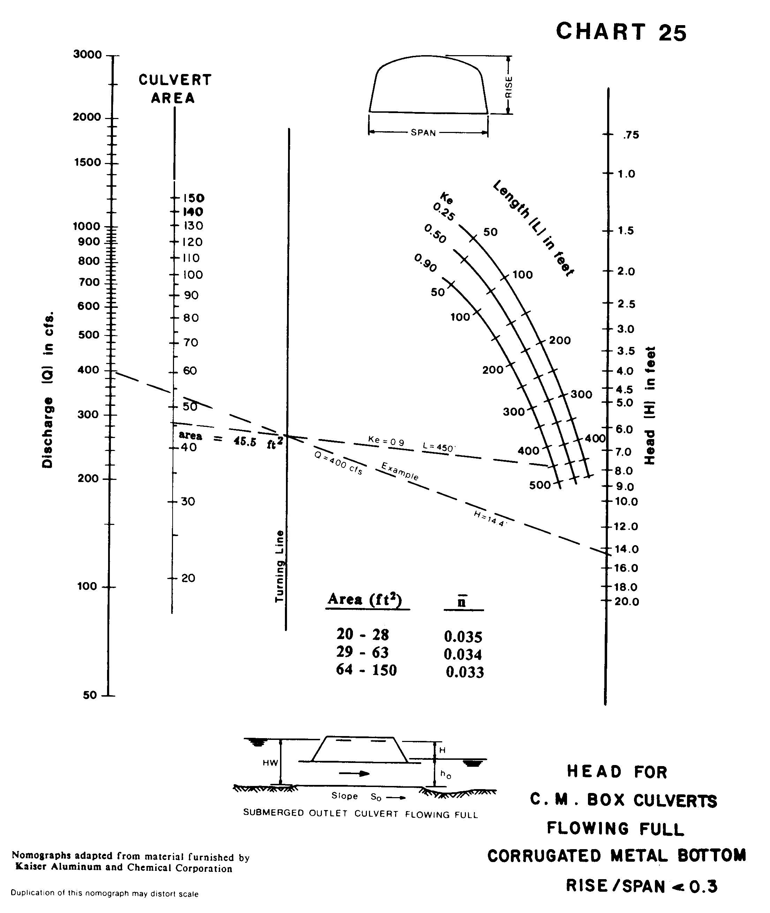

Source: HDS-5

