Appendix 8C-23 Outlet Control, Corrugated Metal Box,

Concrete Bottom, 0.4≤ Rise/Span <0.5
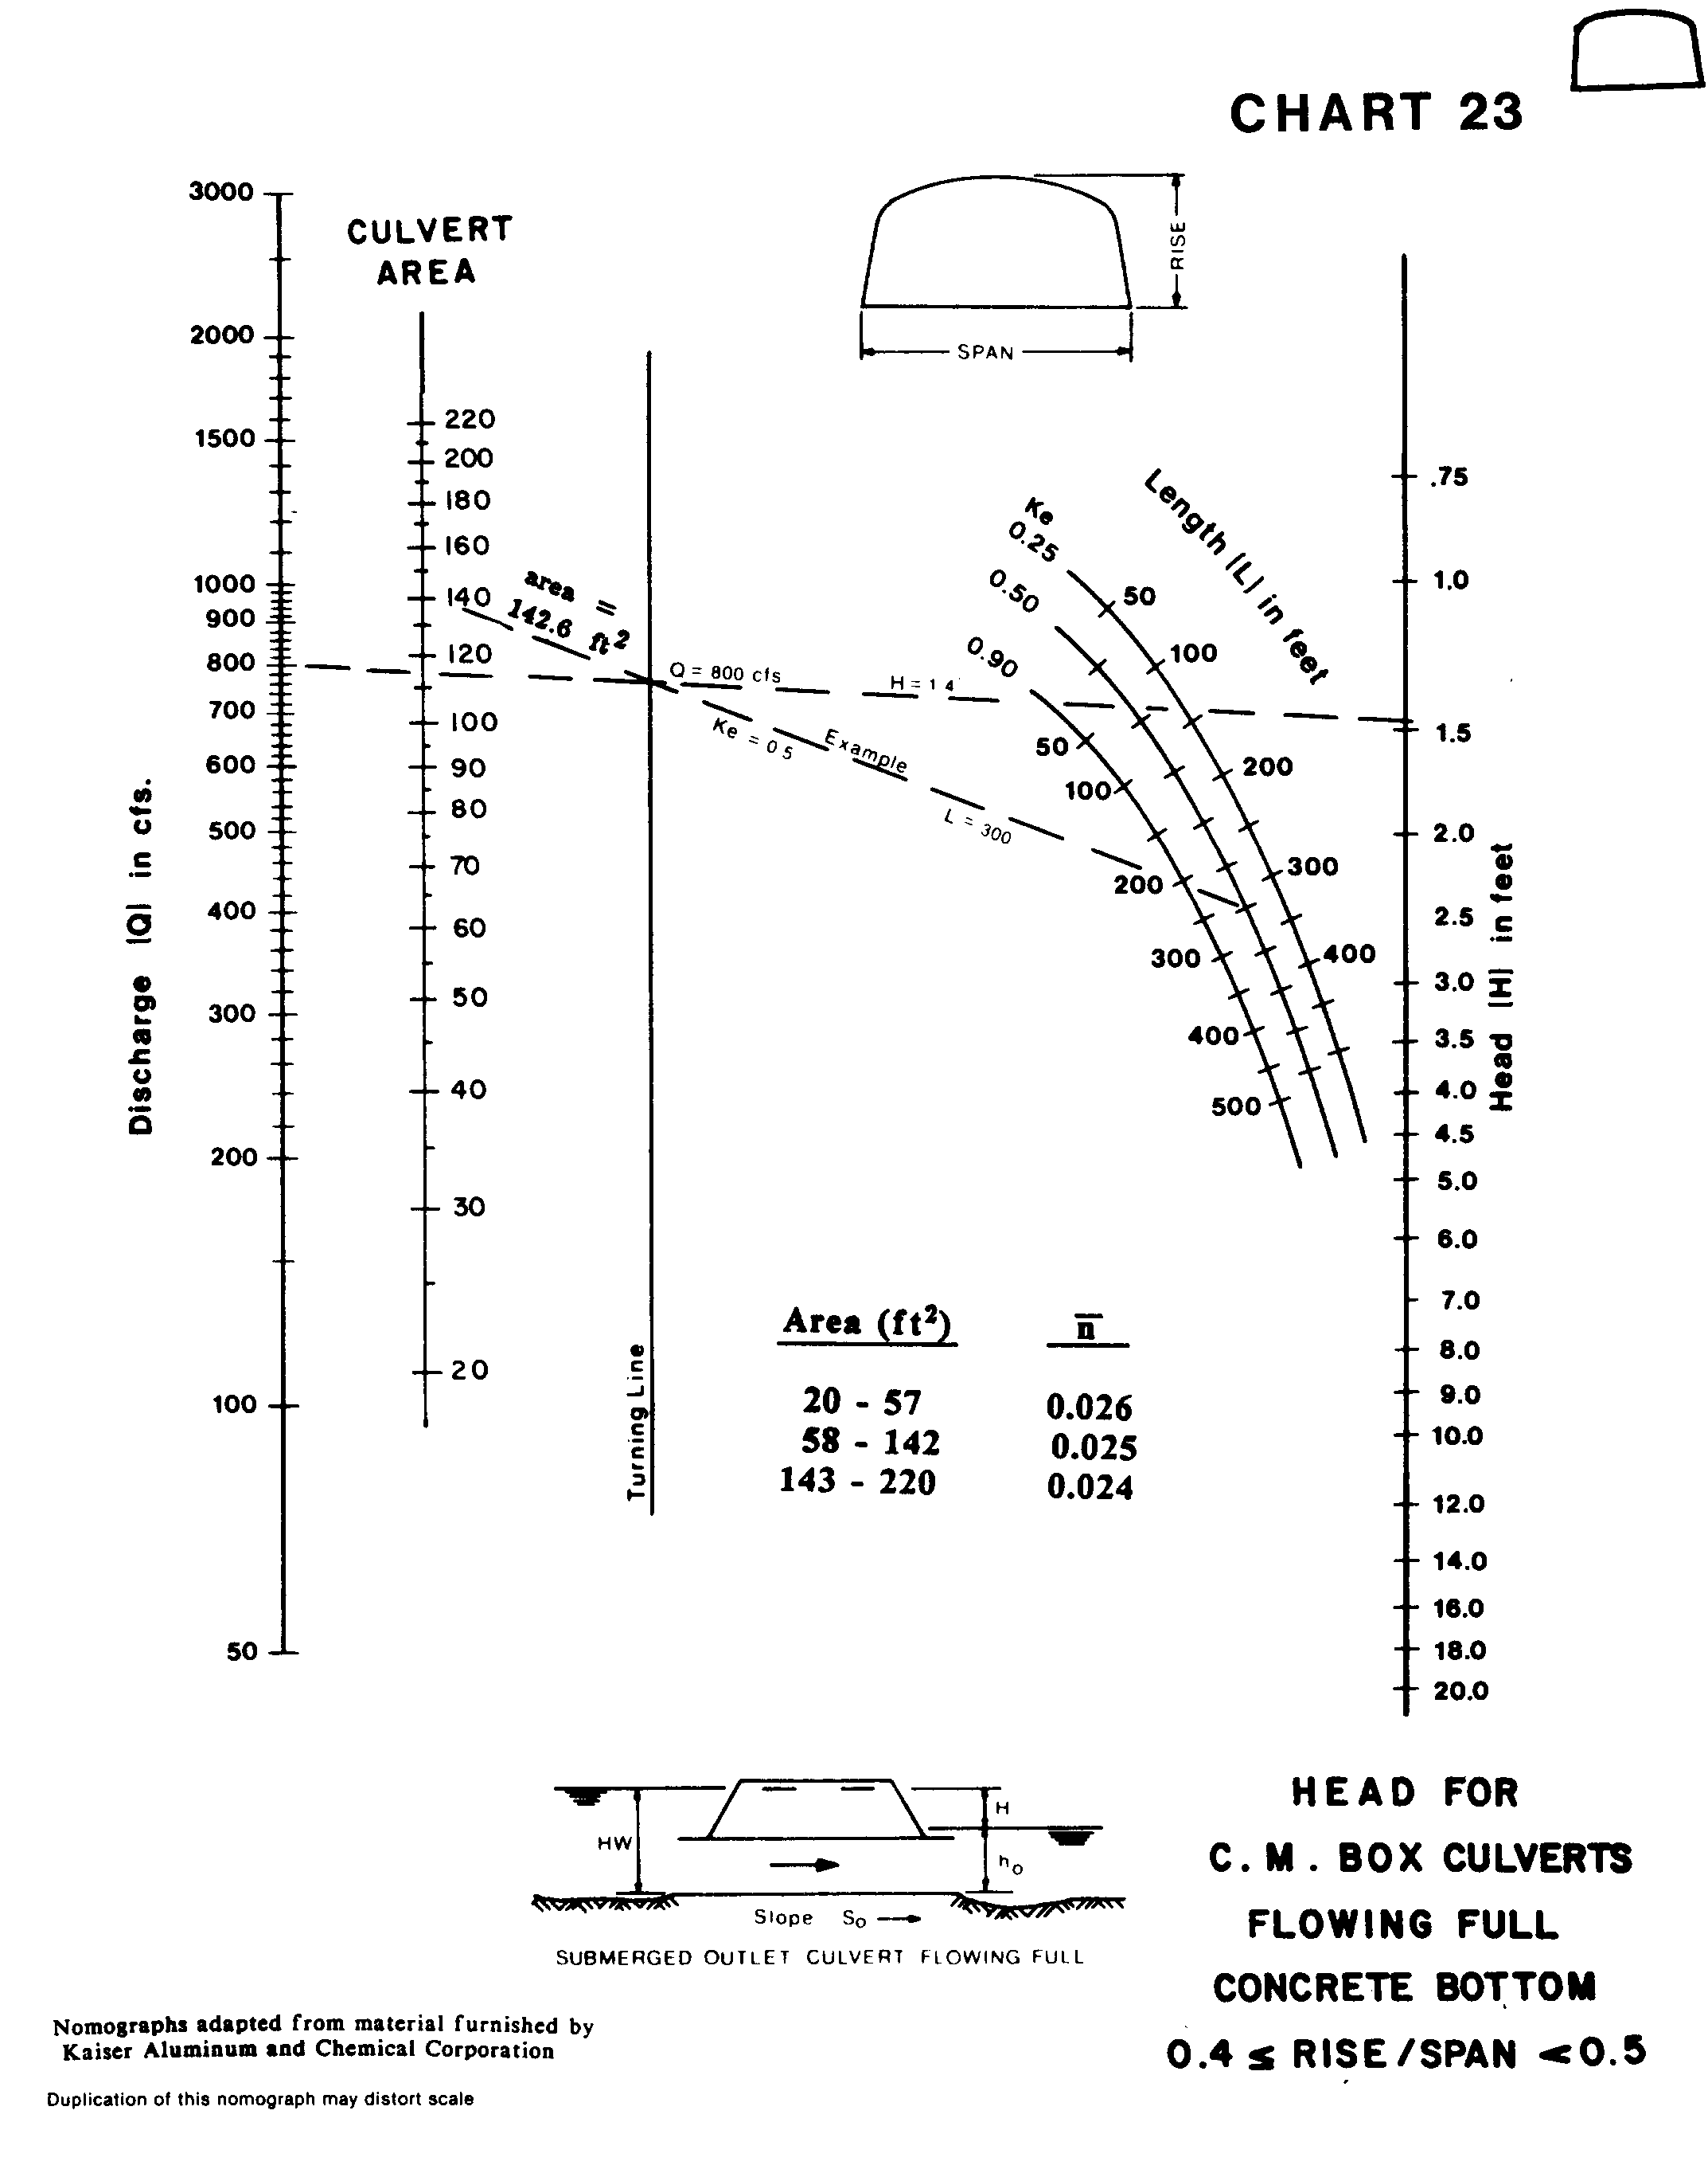

Source: HDS-5

