Appendix 8C-19 Inlet Control,

Corrugated Metal Box,

0.5≤ Rise/Span
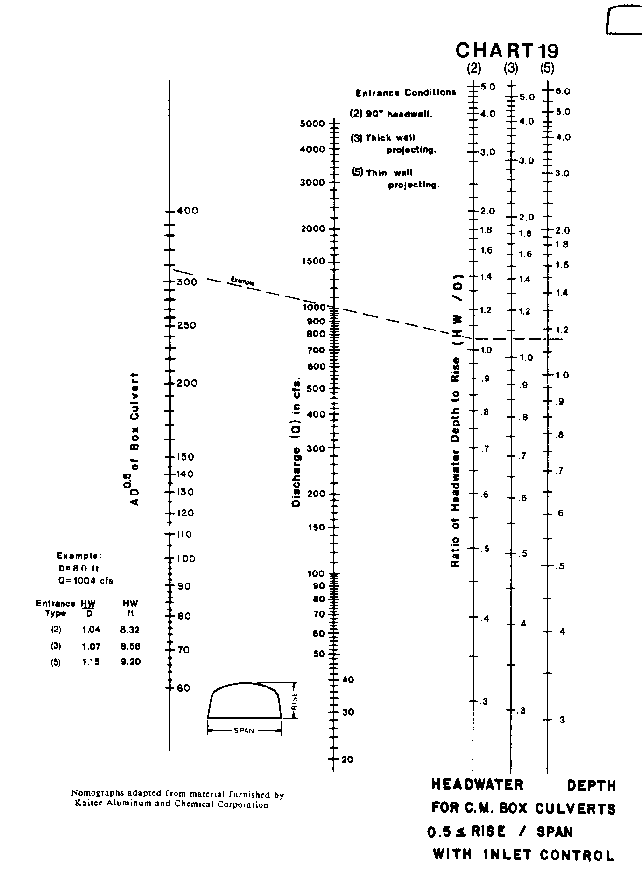

Source: HDS-5

