Appendix 8C-16 Inlet Control,

Corrugated Metal Box,

Rise/Span <0.3
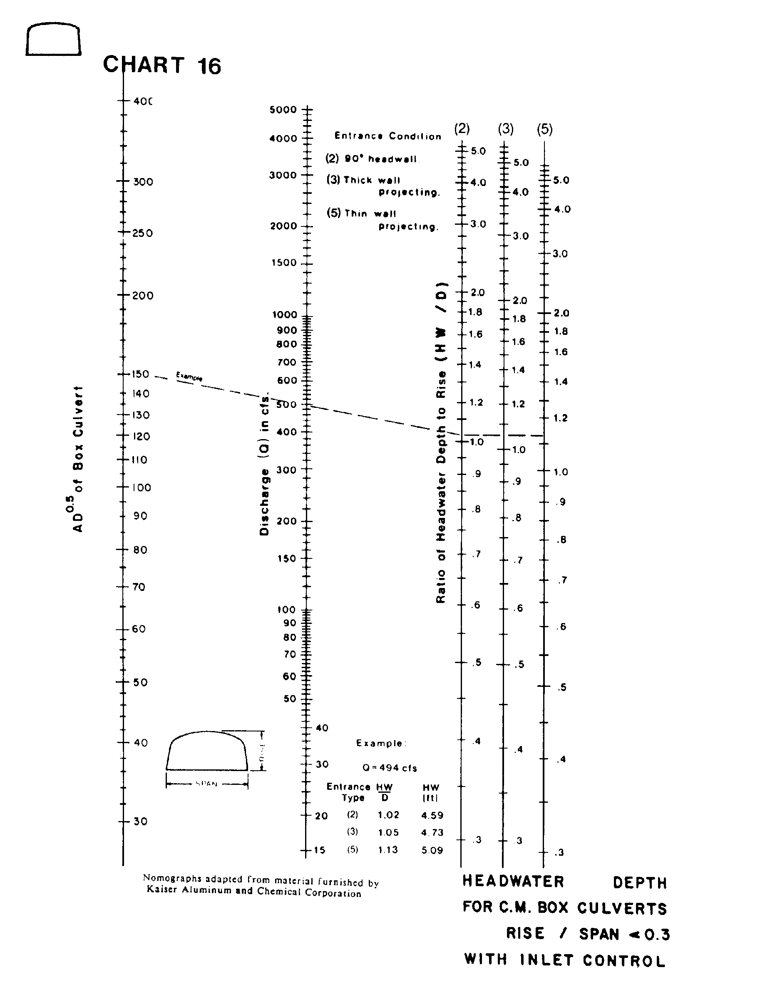

Source: HDS-5

