Appendix 8C-13 Inlet Control, Concrete Box with Offset Flared

Wingwalls, Beveled Top Edge
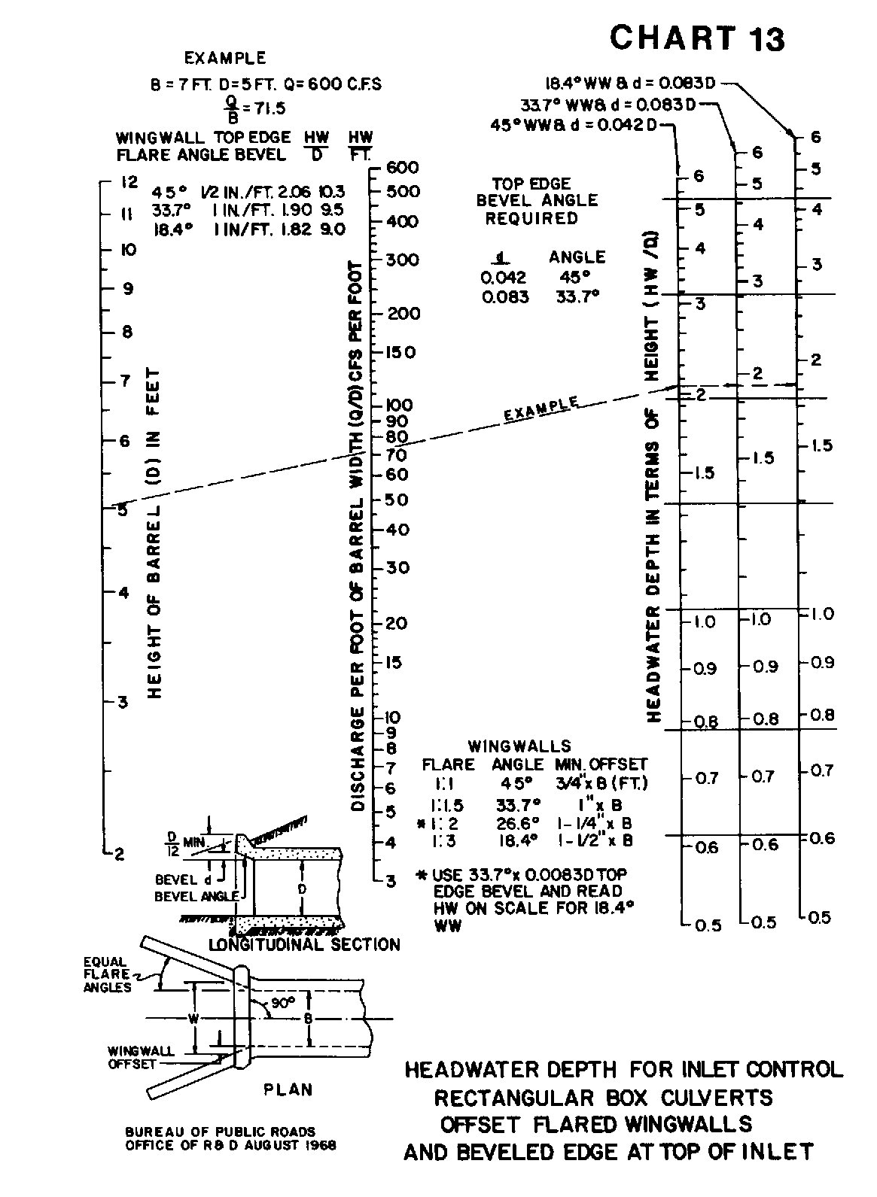

Source: HDS-5

