Appendix 8C-10 Inlet Control, Concrete Box,

90º Headwall,

Chamfered or Beveled Edges

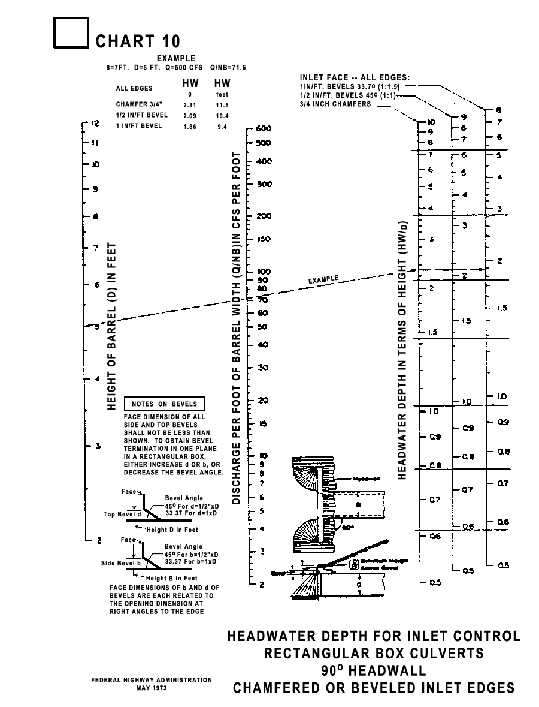

Source: HDS-5

