Appendix 8C-8 Inlet Control, Concrete Box
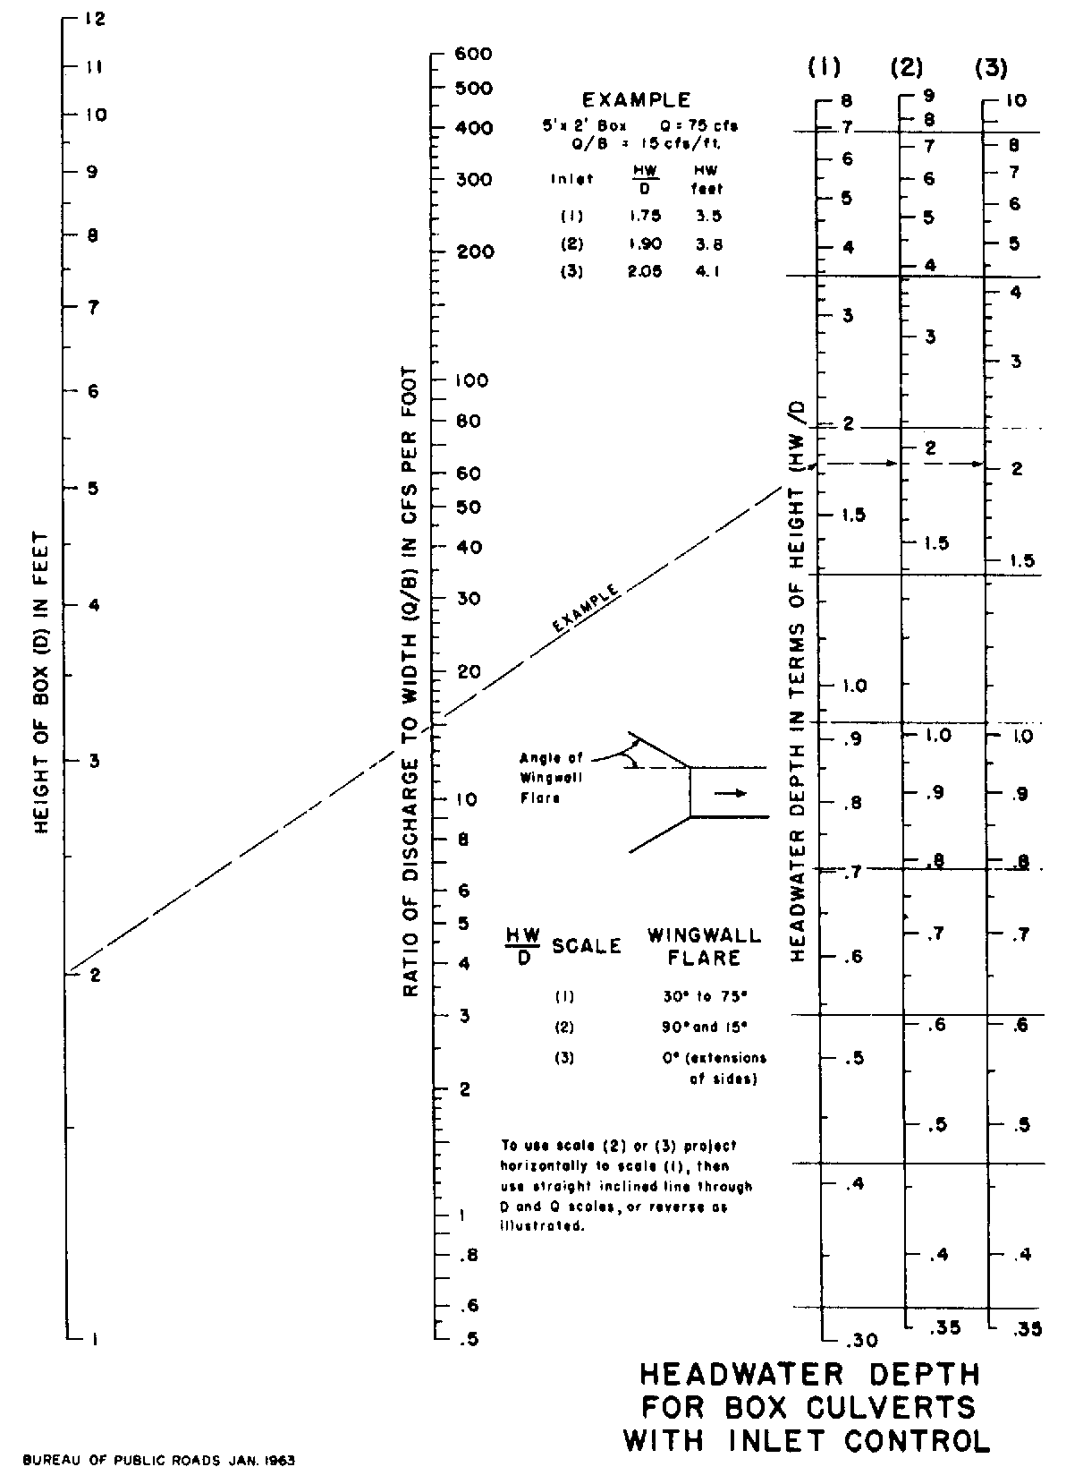

Source: HDS-5

