Appendix 8C-7 Outlet Control,

Circular Structural Plate Corrugated Metal

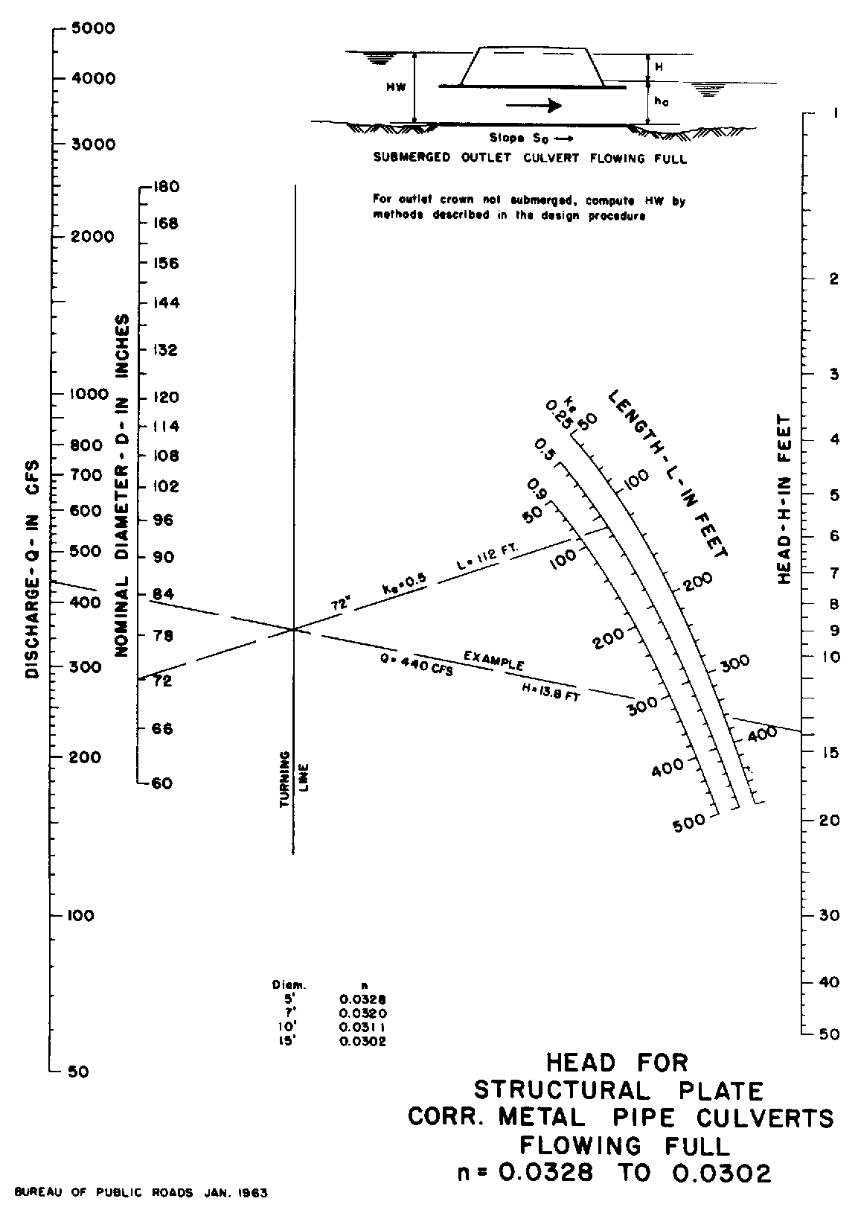

Source: HDS-5

