Appendix 8C-5 Outlet Control, Circular Concrete
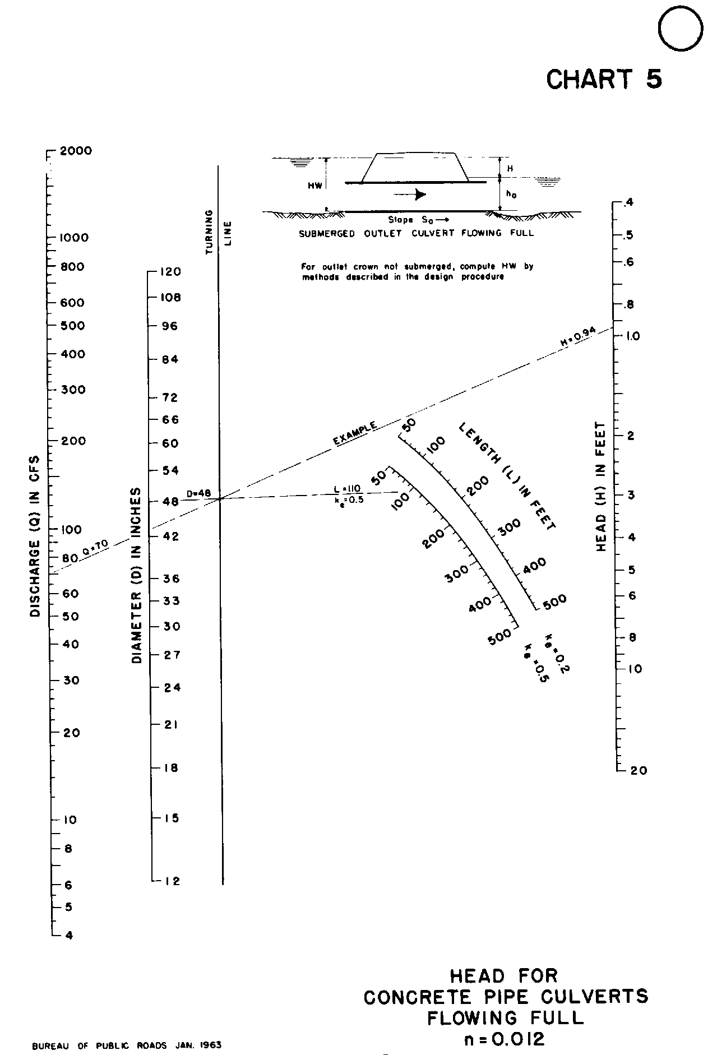

Source: HDS-5

