Appendix 7E-7 Channel Side Shear Stress

to Bottom Shear Stress Ratio

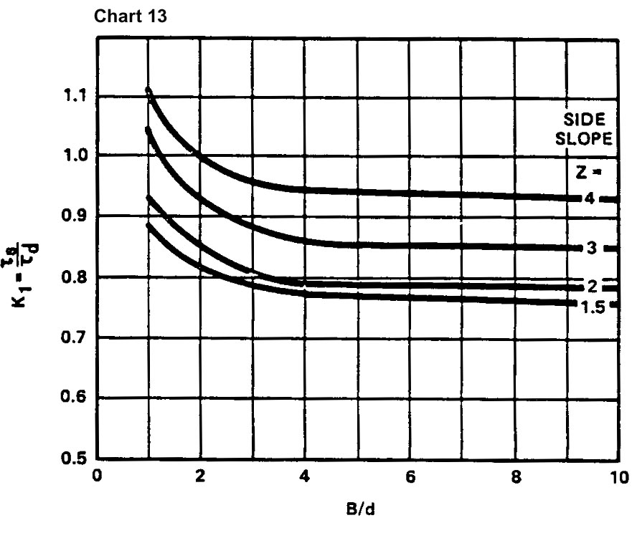

Source: HEC-15

