Appendix 7E-5 Correction Factor for Riprap Size
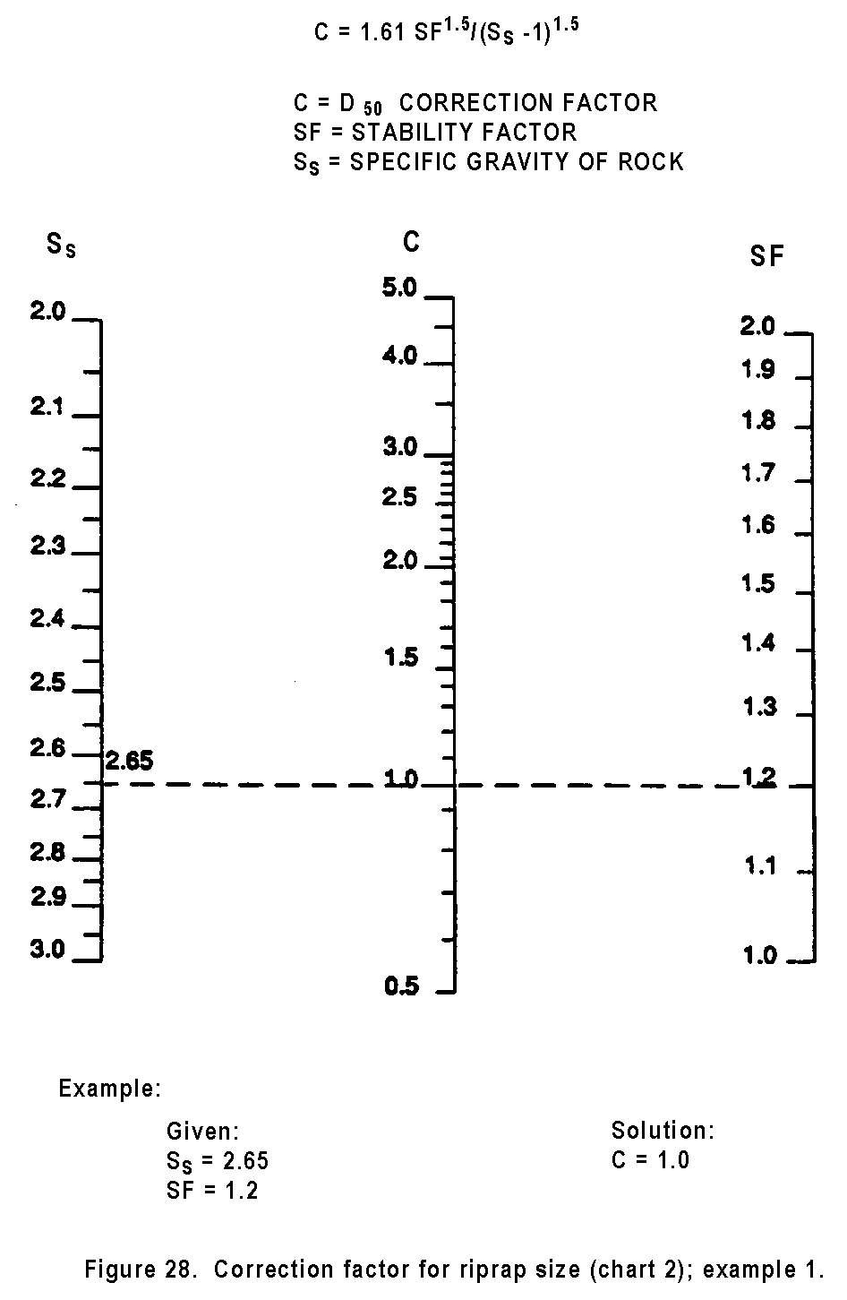

Source: HEC-11

Comment: S_{s}=S_{g} (text)

