Appendix 7E-1 Angle of Repose of Riprap in

Terms of Mean Size and Shape of Stone

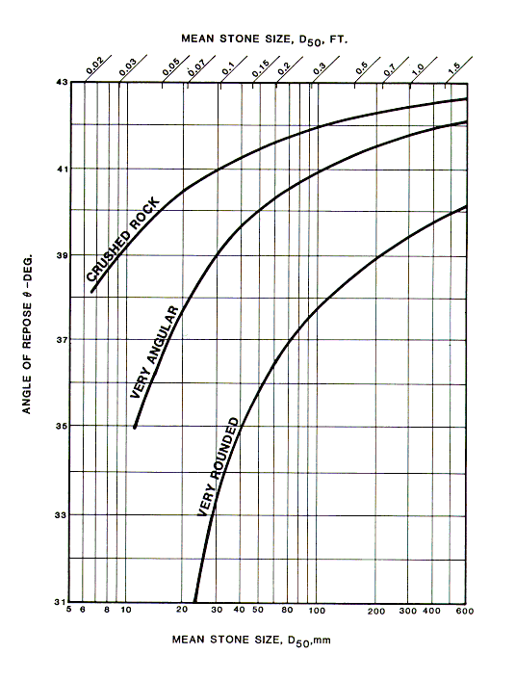

Source: HEC-15

