Appendix 7C-29 Trapezoidal Channel Flow Chart

(B = 16’, Side Slopes = 2:1)

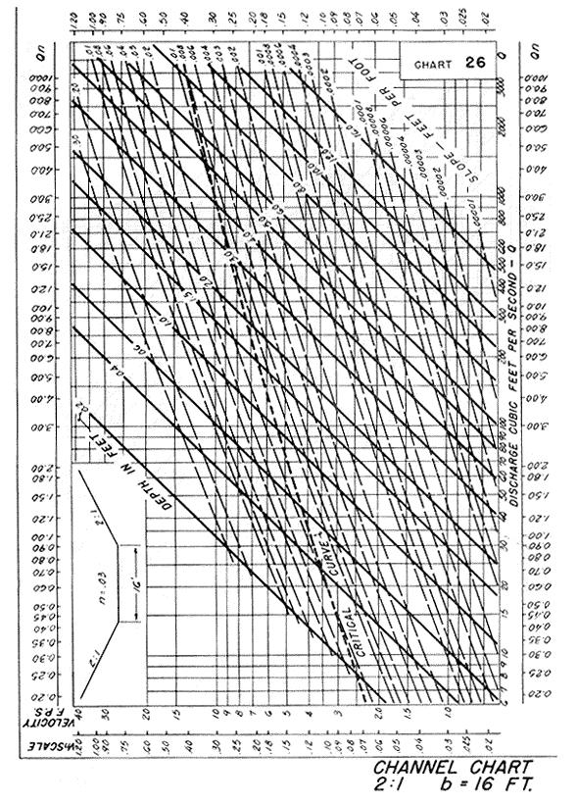

Source: HDS-3

