Appendix 7C-28 Trapezoidal Channel Flow Chart

(B = 14’, Side Slopes = 2:1)

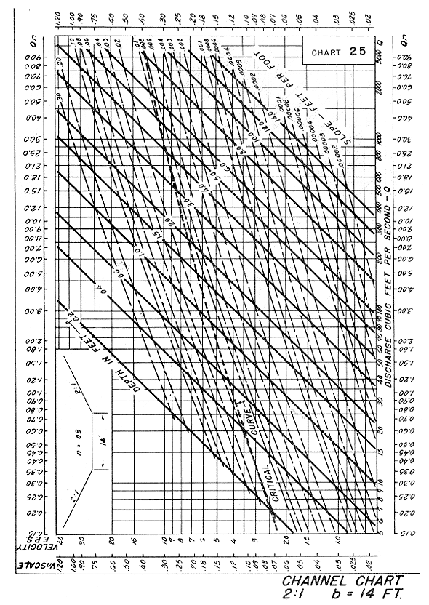

Source: HDS-3

