Appendix 7C-25 Trapezoidal Channel Flow Chart

(B = 9’, Side Slopes = 2:1)

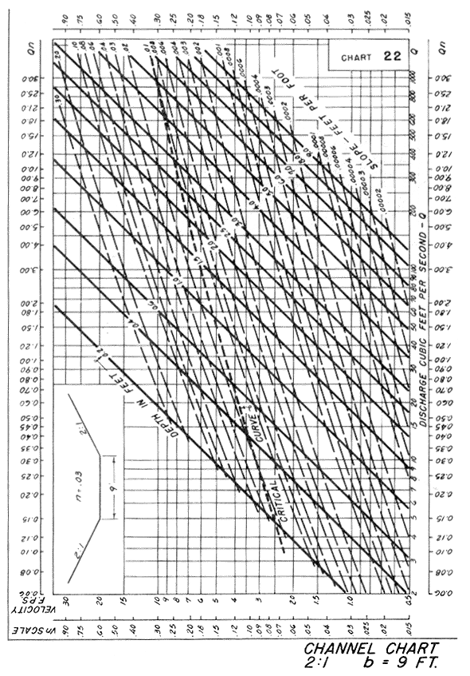
Source: HDS-3

