Appendix 7C-23 Trapezoidal Channel Flow Chart

(B = 7’, Side Slopes = 2:1)

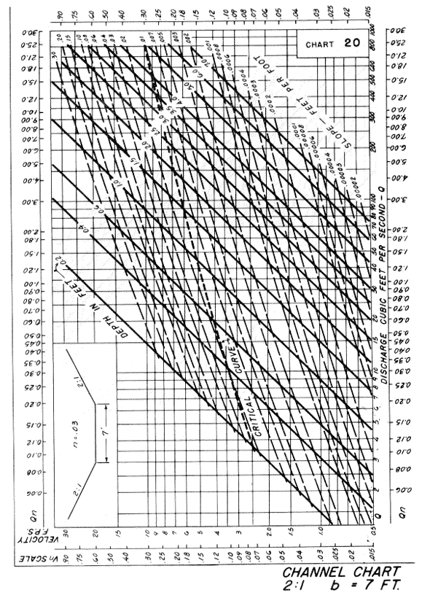

Source: HDS-3

