Appendix 7C-22 Trapezoidal Channel Flow Chart

(B = 6’, Side Slopes 2:1)

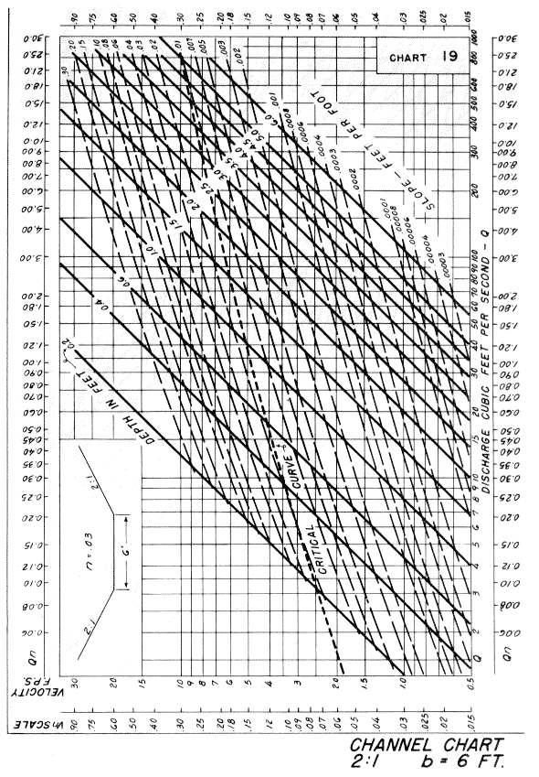
Source: HDS-3

