Appendix 7C-20 Trapezoidal Channel Flow Chart

(B=4’, Side Slopes = 2:1)

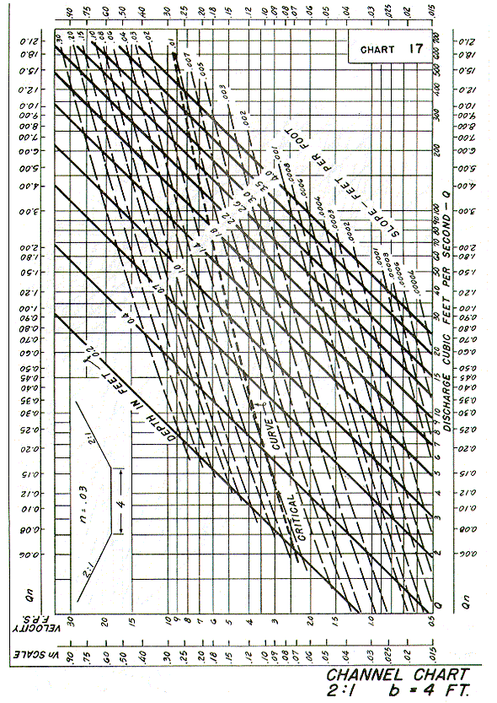

Source: HDS-3

