Appendix 7C-15 Toe Ditch Flow Chart

(Side Slopes = 1.5:1, 1.5:1)

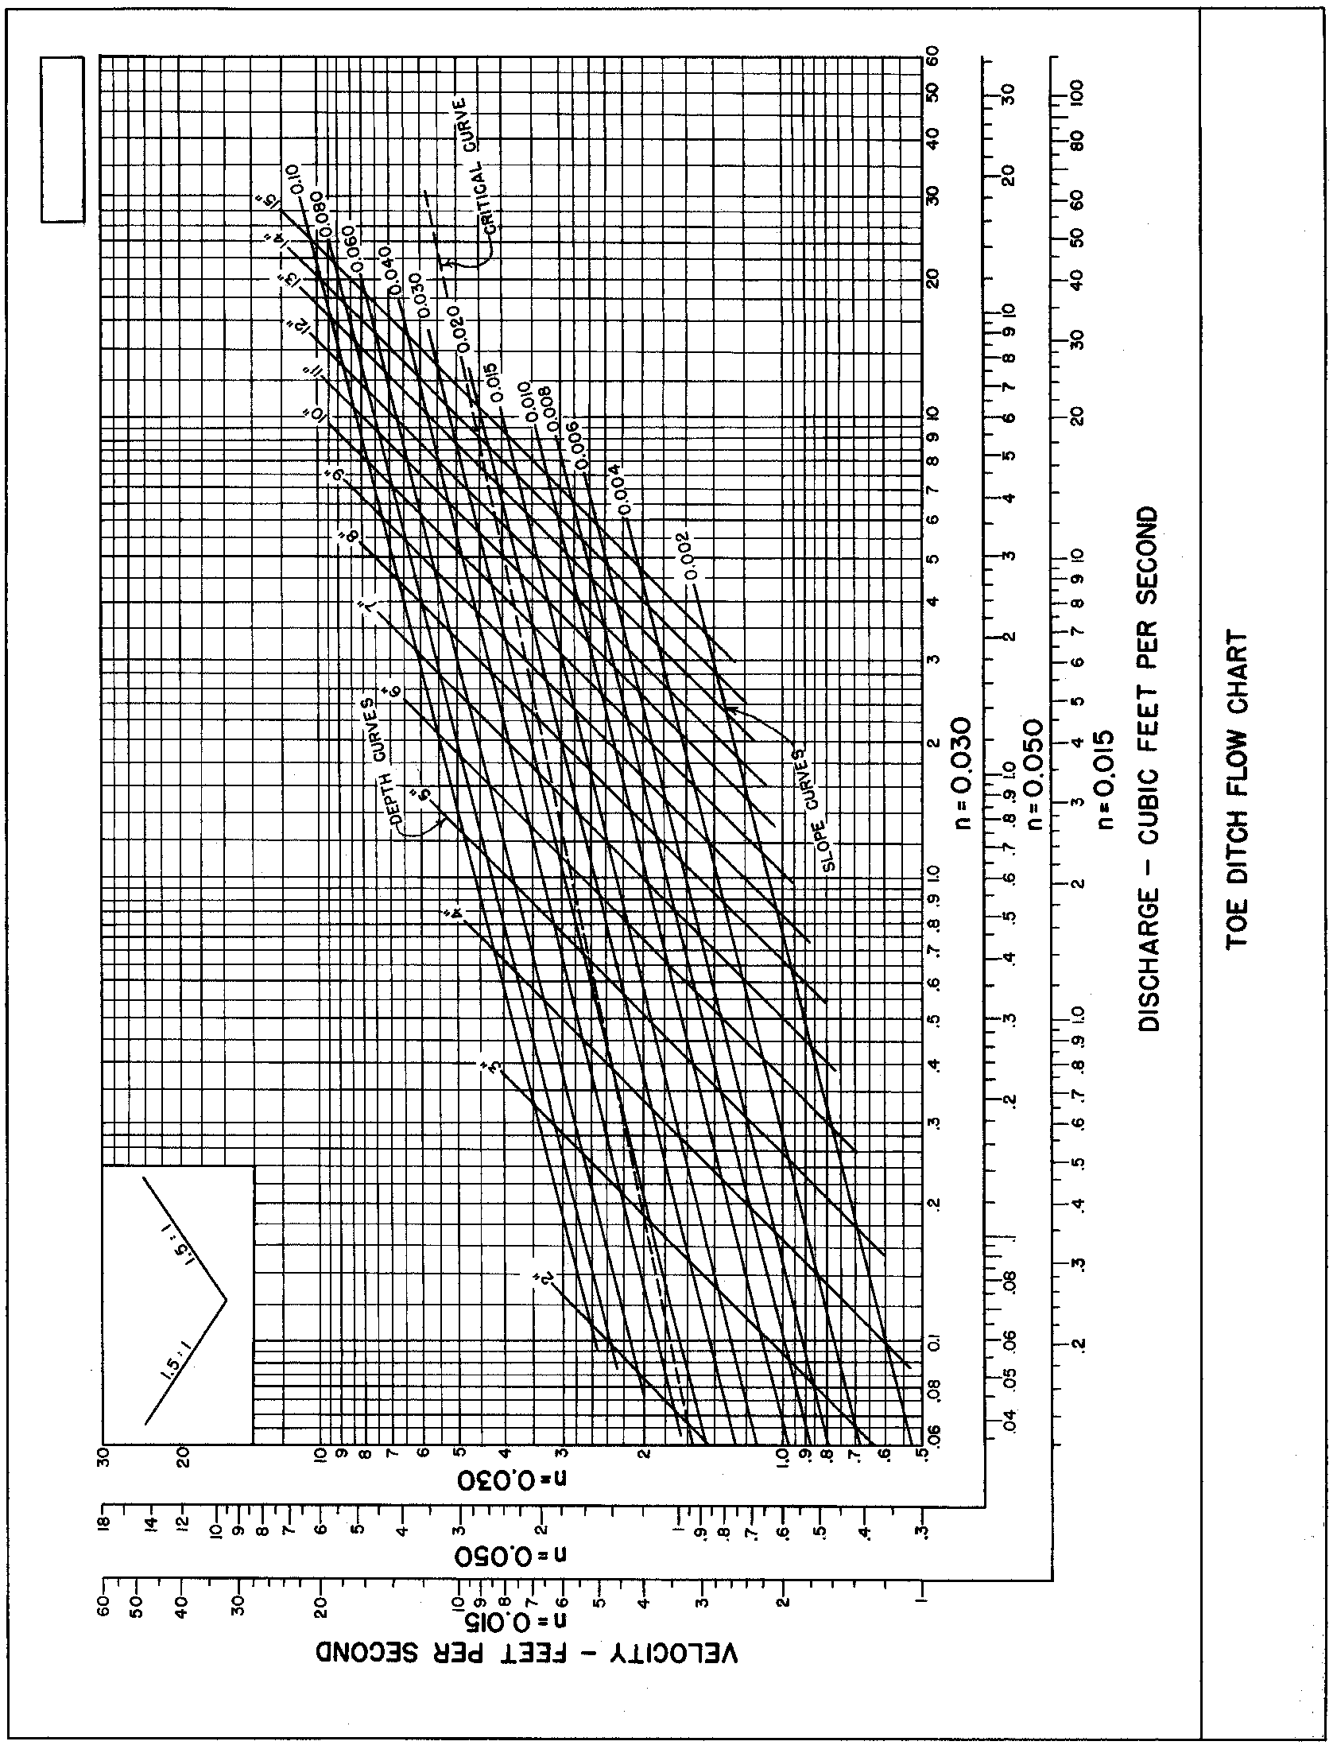

Source: VDOT

