Appendix 7C-14 Triangular Median Ditch Flow Chart

(Side Slopes = 2:1, 2:1)

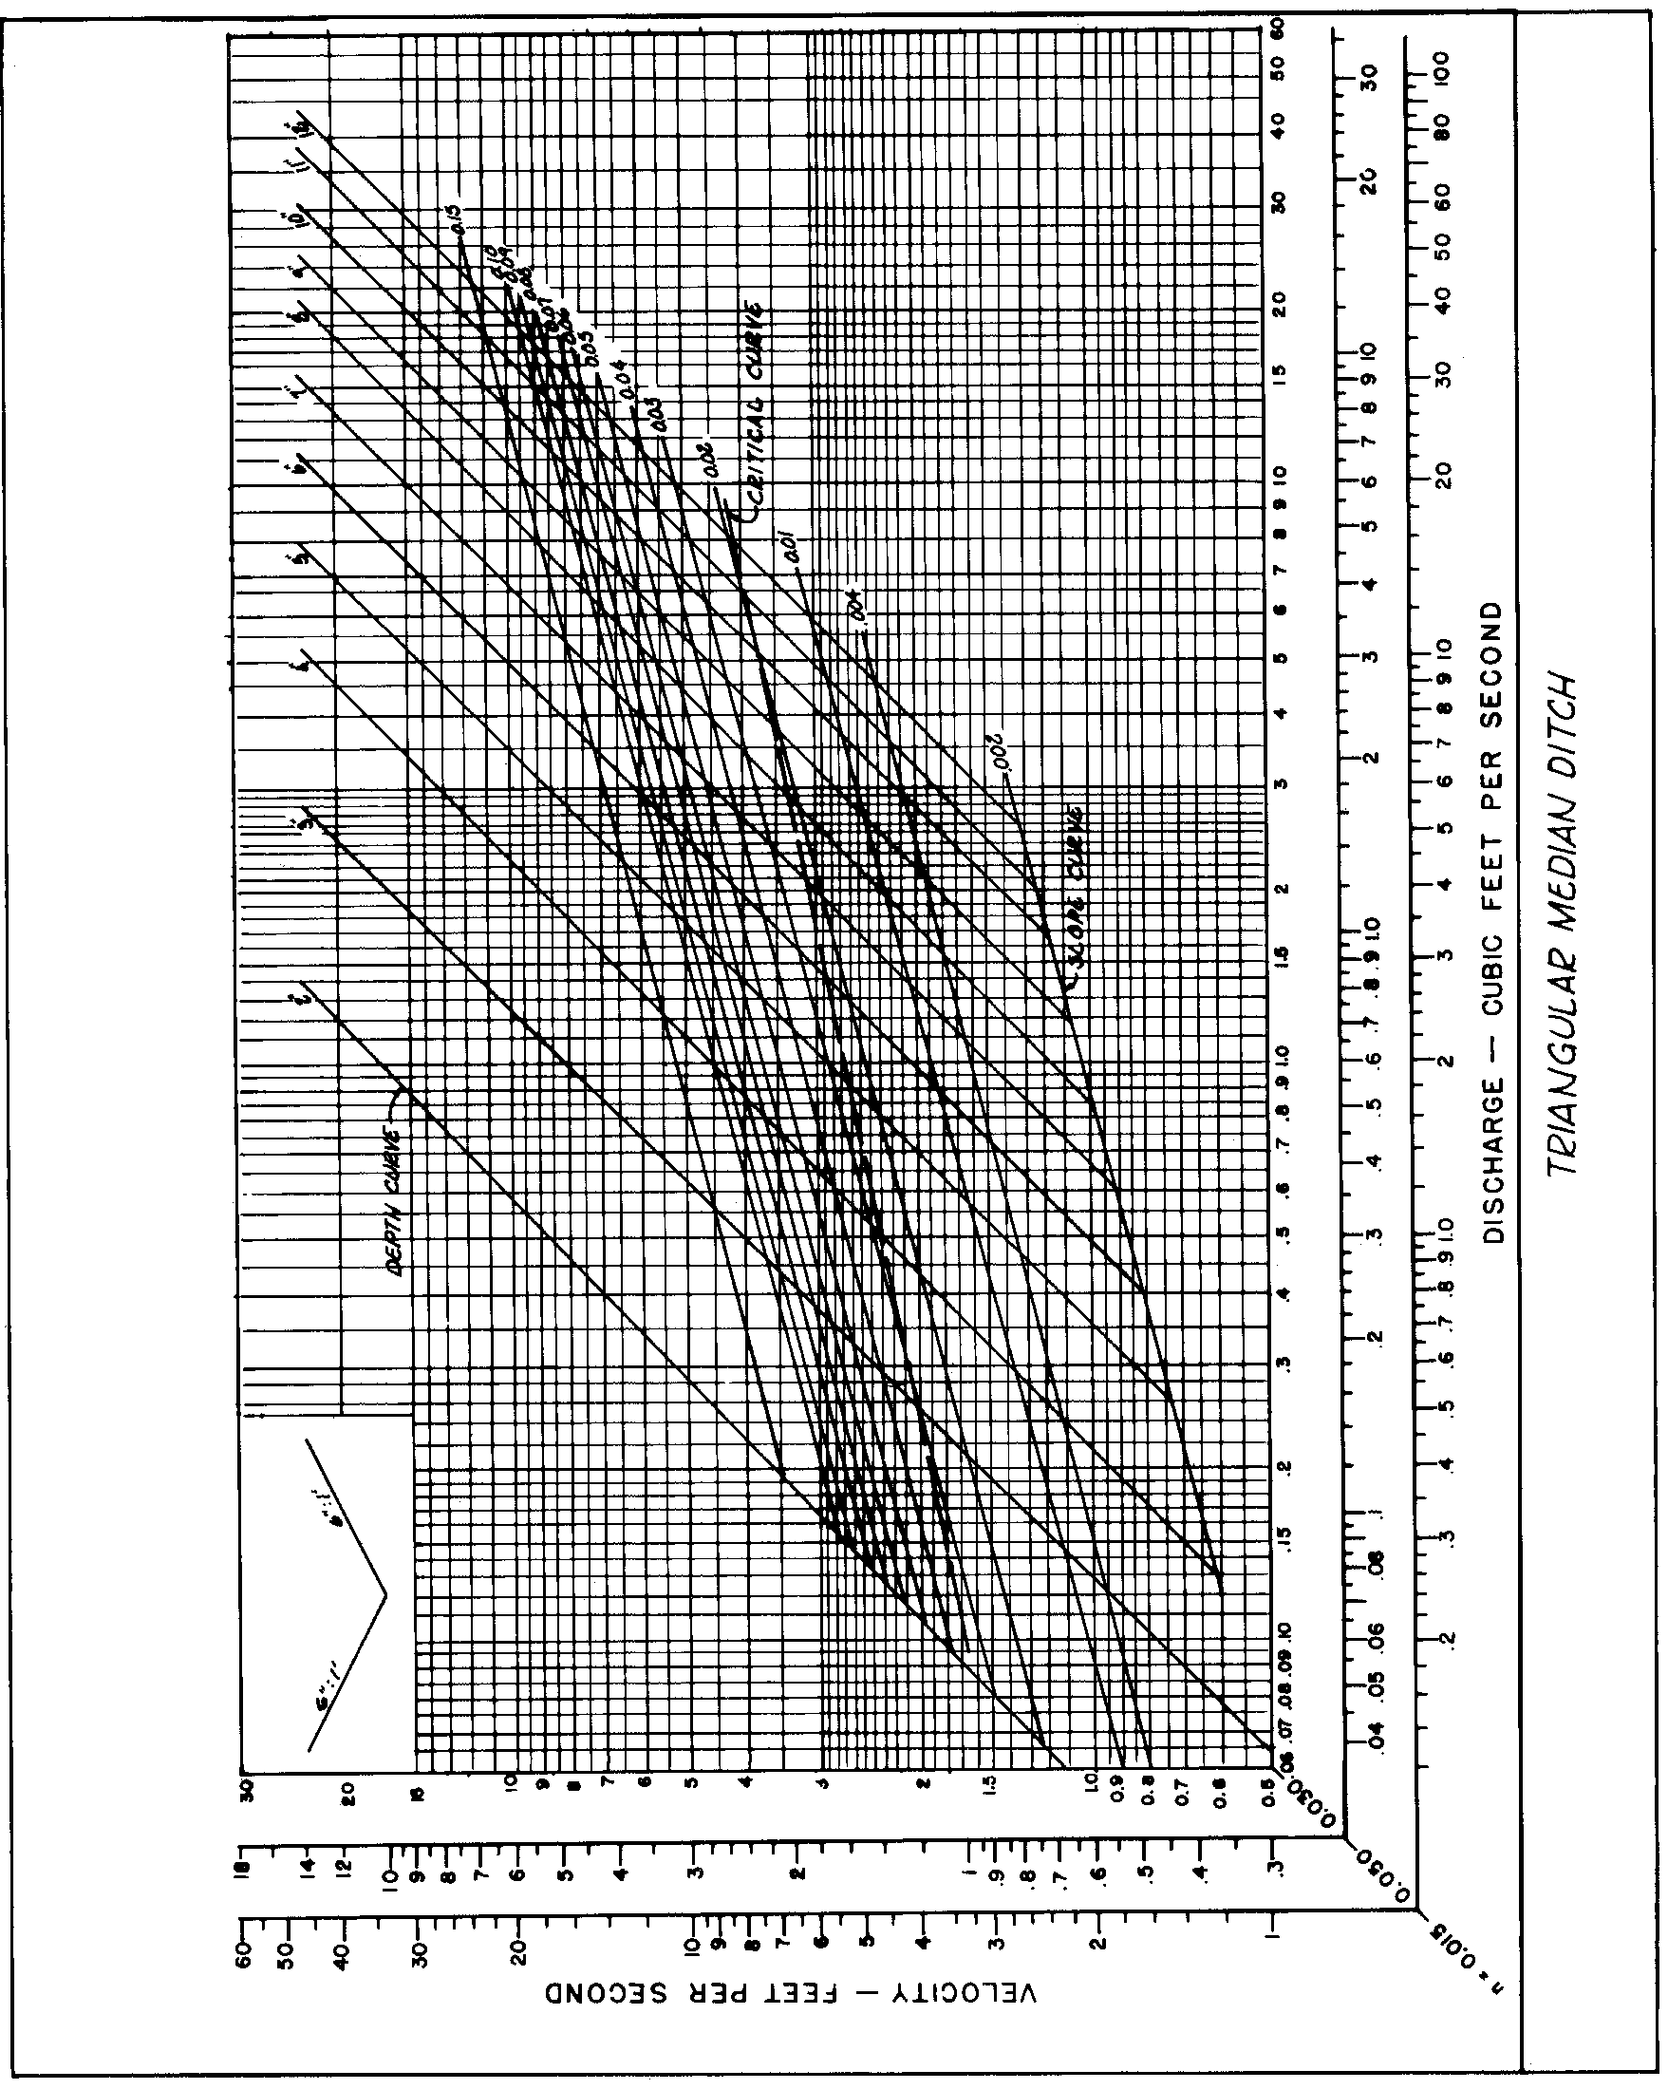

Source: VDOT

